**WALMART TIME SERIES FORECASTING**

**PROBLEM STATEMENT**

A retail store that has multiple outlets across the country are facing issues in managing the inventory - to match the demand with respect to supply.

**PROJECT OBJECTIVE**

The objective of this project is to use Statistical analysis to bring out various insights about the data by exploring multiple features and answering key questions that affects the sales of stores.

Creating a time series model to predict the sales of 3 or more stores.

In this study, we aim to thoroughly examine how both internal and external factors impact the forthcoming weekly sales of one of the largest enterprises in the United States. This investigation encompasses comprehensive data analysis, incorporating time series examination, pinpointing the top-performing outlets, and conducting sales prognostication

**DATA DESCRIPTION**

Forecasting future sales for a corporation stands as a pivotal component of strategic planning.

The dataset utilized spans from 2010 to 2012, encompassing 45 Walmart stores nationwide.

Notably, supplementary external data such as CPI, unemployment rates, and fuel prices in the vicinity of each store are also at our disposal, potentially enriching the depth of our analysis.

This dataset has 6435 rows and 8 columns

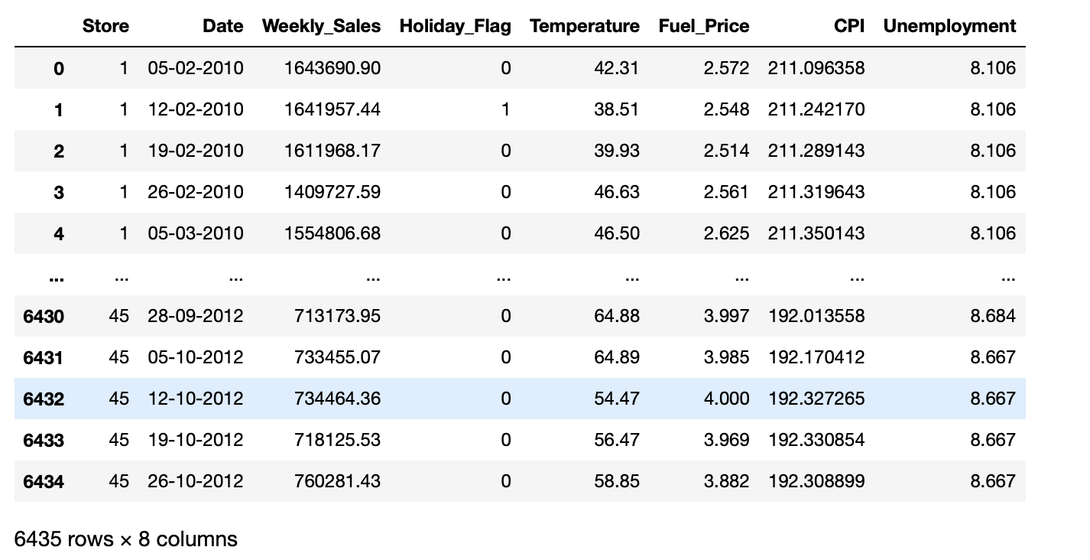

**FEATURES AND DESCRIPTION**

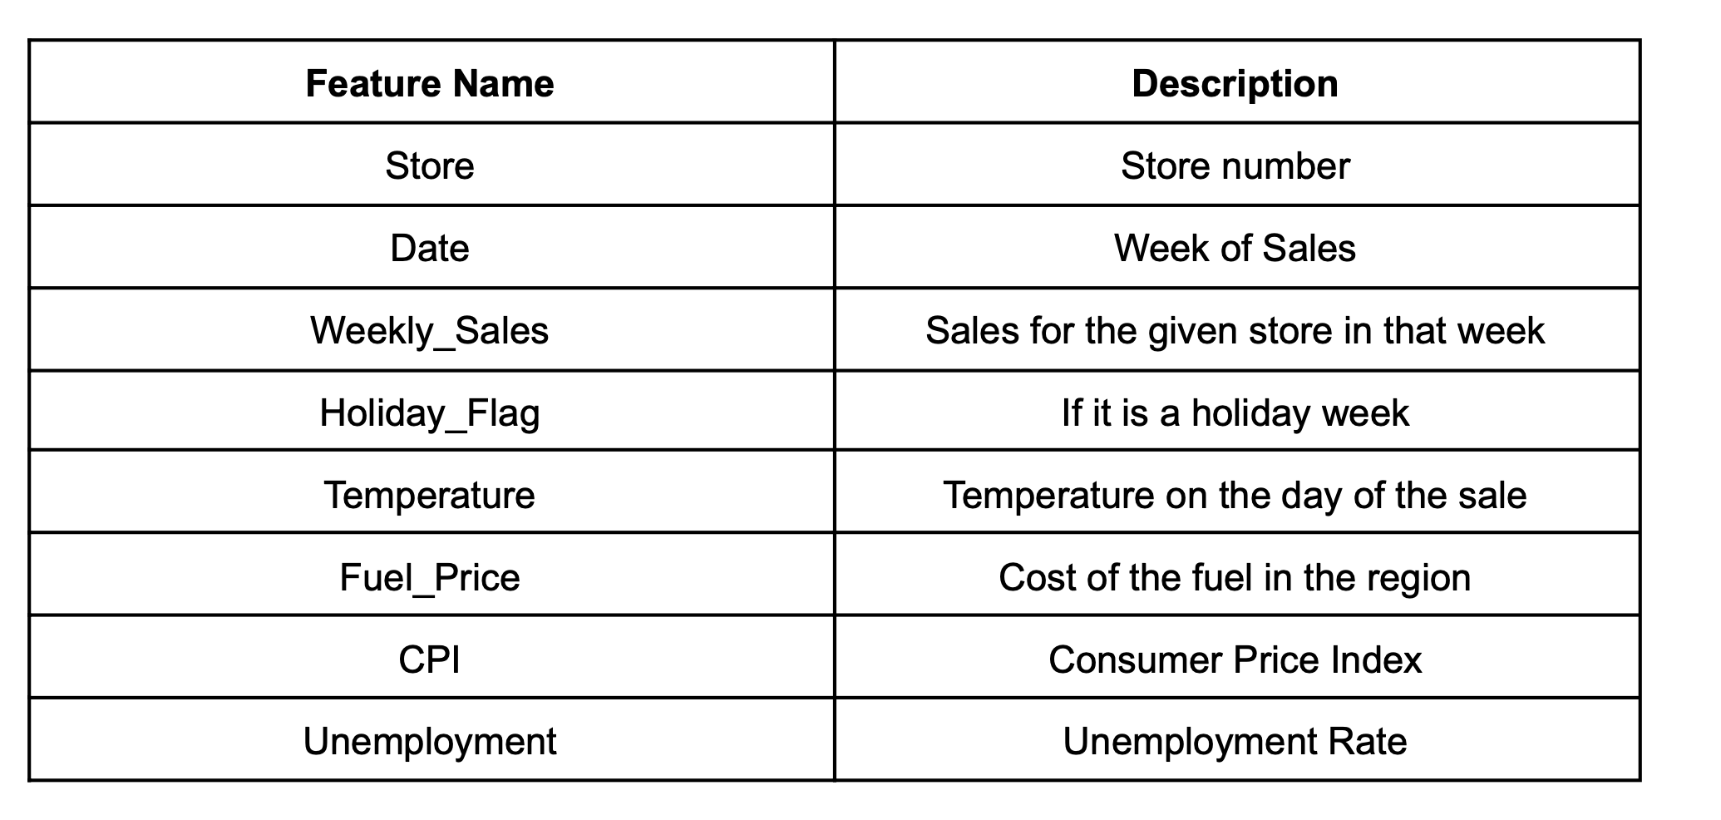

**PRELIMINARY INSIGHTS**

* Data has 8 columns.
* Two integer columns and rest are all float.
* Date column is in object format and needs to be converted into date time
* The holiday week column is already label encoded.

**DATA PREPROCESSING AND INSPIRATION**

The time column is not in datetime format, so the first pre-processing step would be to convert it into date time format

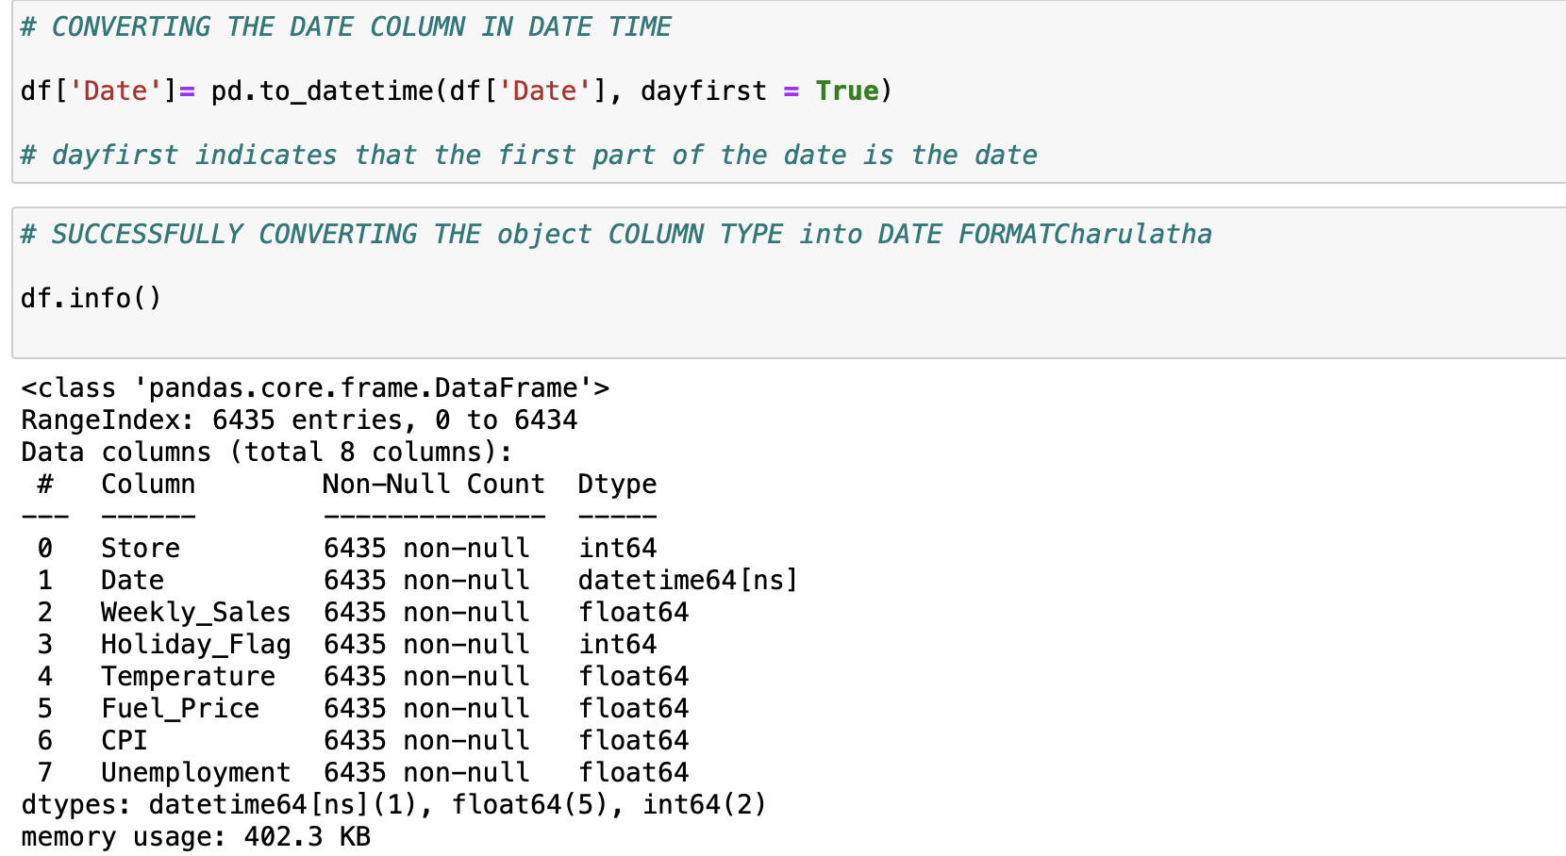

**DESCRIPTIVE STATISTICS OF NUMERICAL FEATURES**

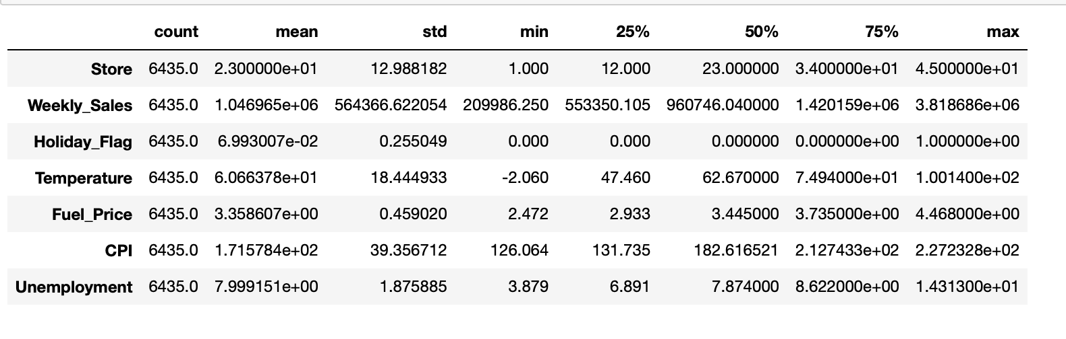

* There are 45 stores in the data.
* The weekly sales of all stores average at 1046965
* There were 450 holiday weeks across stores and 5985 non holiday weeks
* So, averaging out number of stores as 45, there were 10 holiday weeks and 133 non holiday weeks
* The dates are from 2010 Jan to 10 Dec 2012, so around 2 years of data has been captured.
* Fuel price averages around 3.35 and hits a max of 4.46.
* CPI ranges from 126 to 227 across stores and time

**DATA CLEANING**

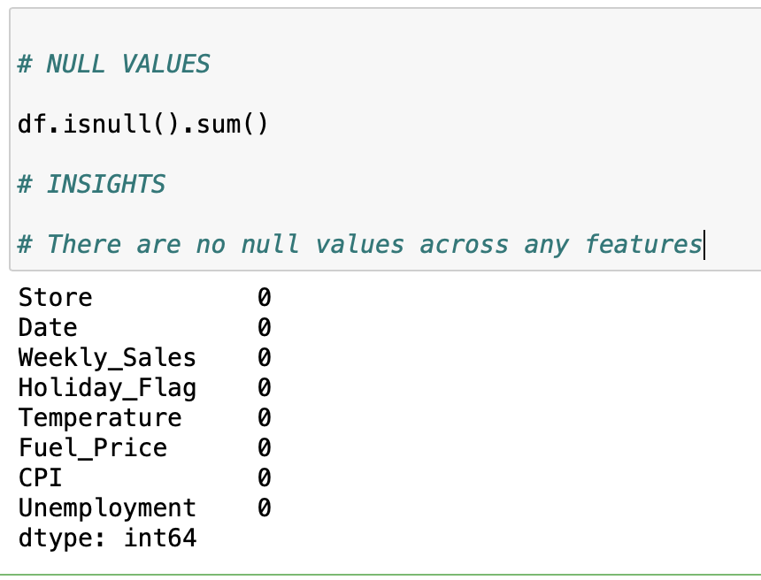

There are no null values in the dataset. But, this doesn’t show the presence of special characters.

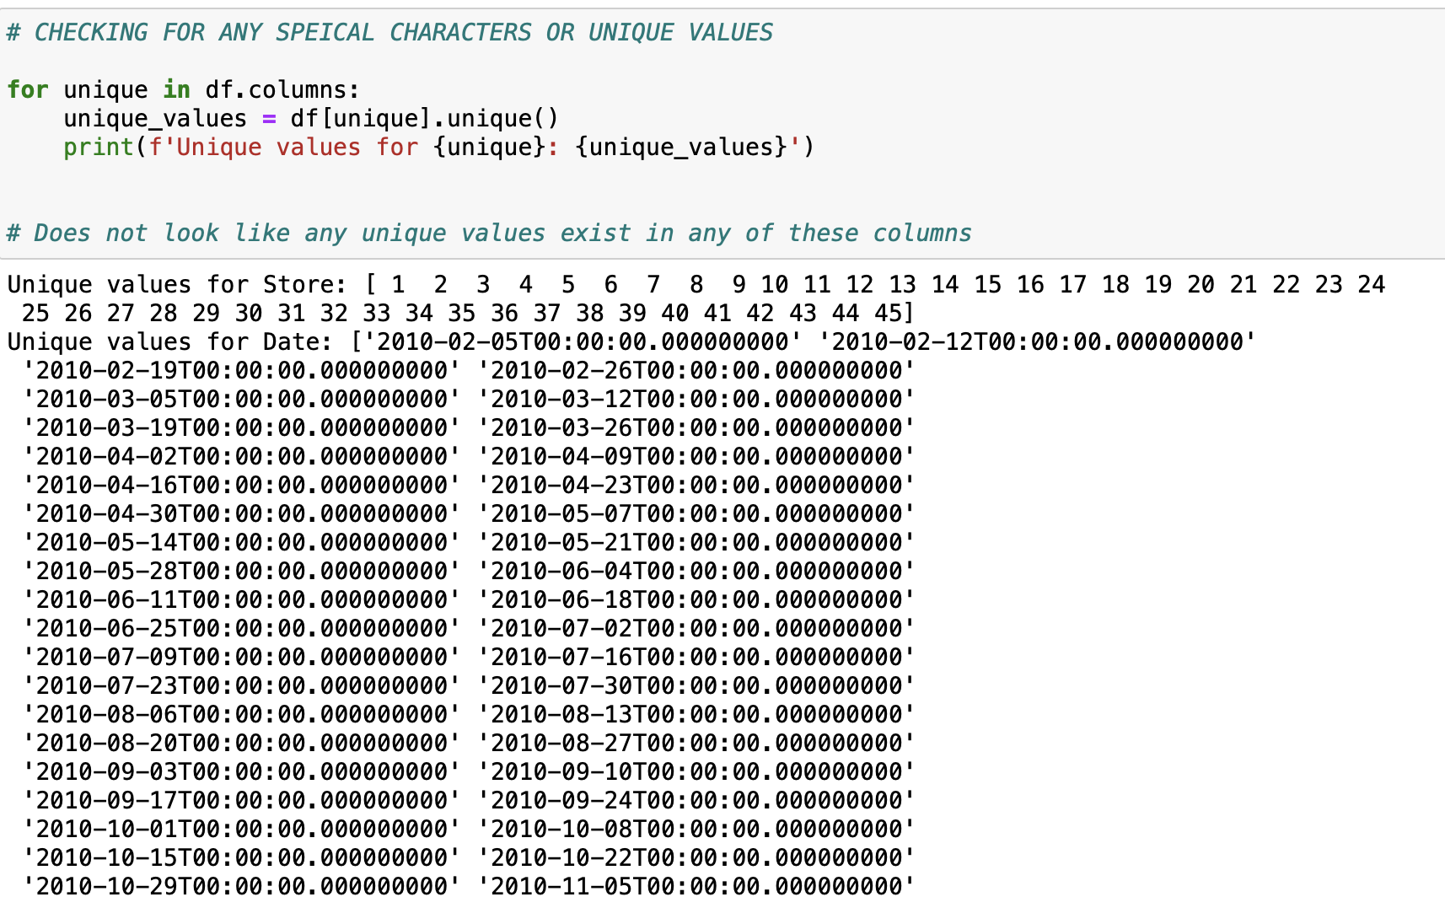

**DUPLICATE DATA**

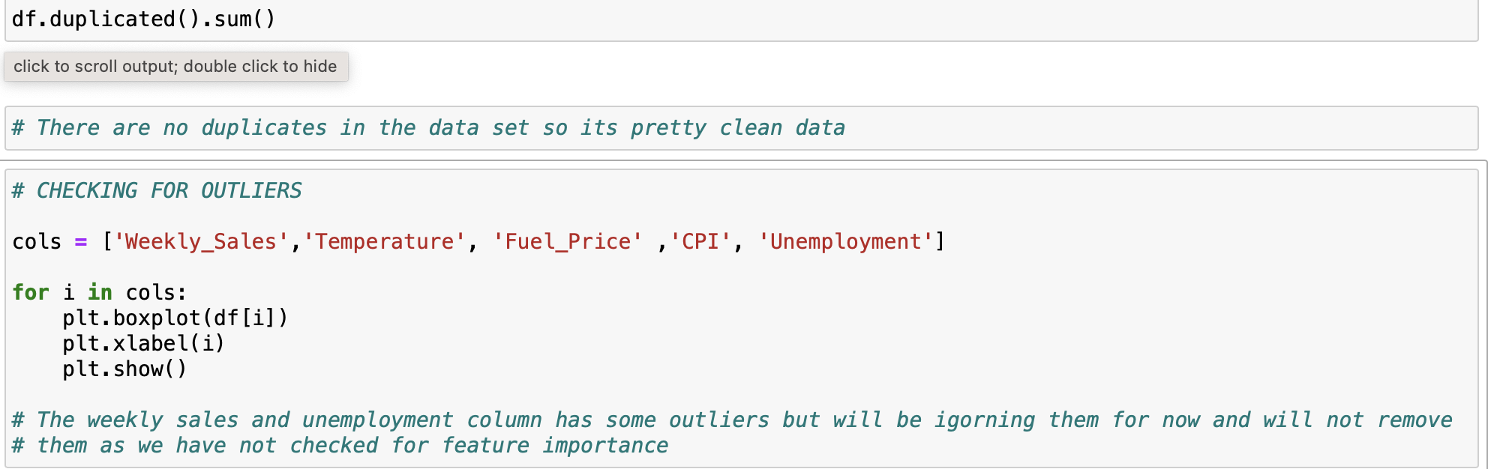

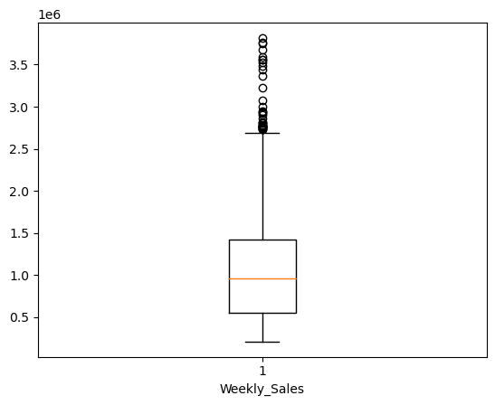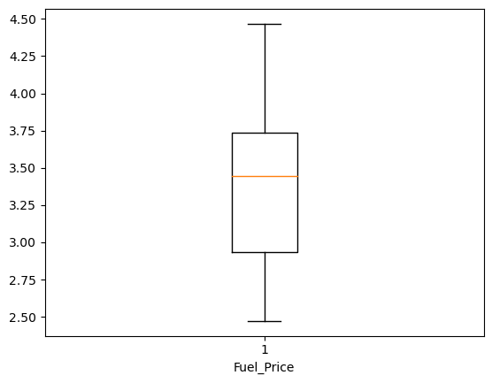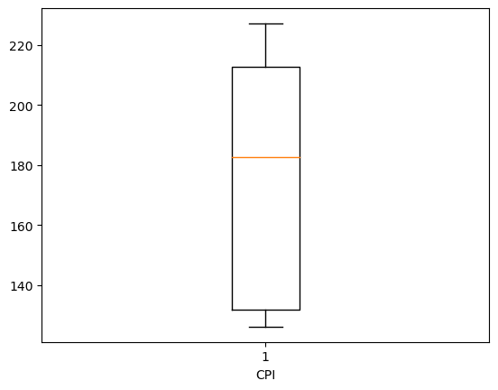 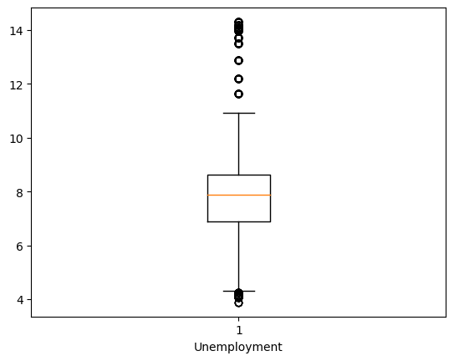

**FEATURE CORRELATION**

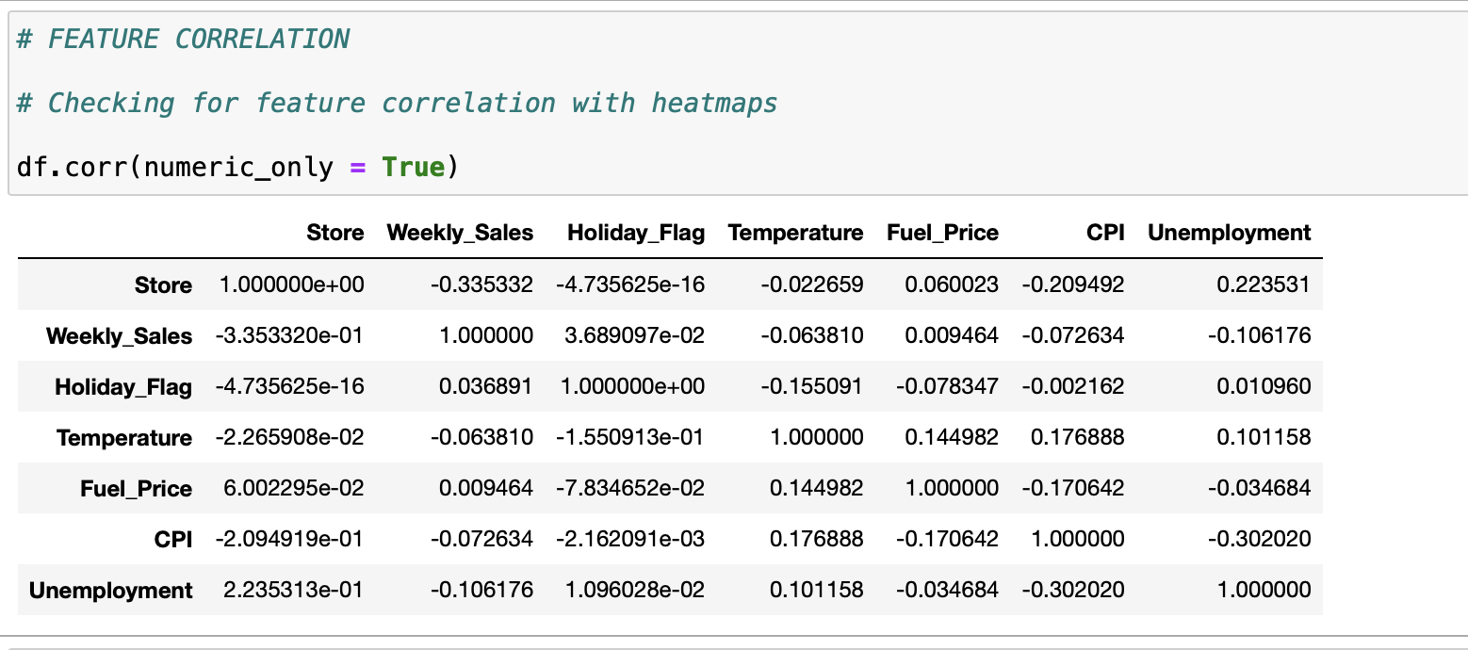

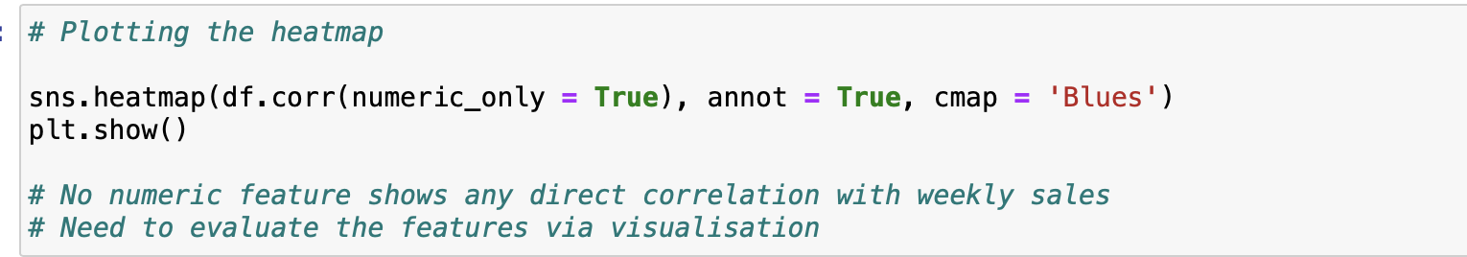

* No numeric feature shows any direct correlation with weekly sales.
* Need to evaluate the features via visualisation.

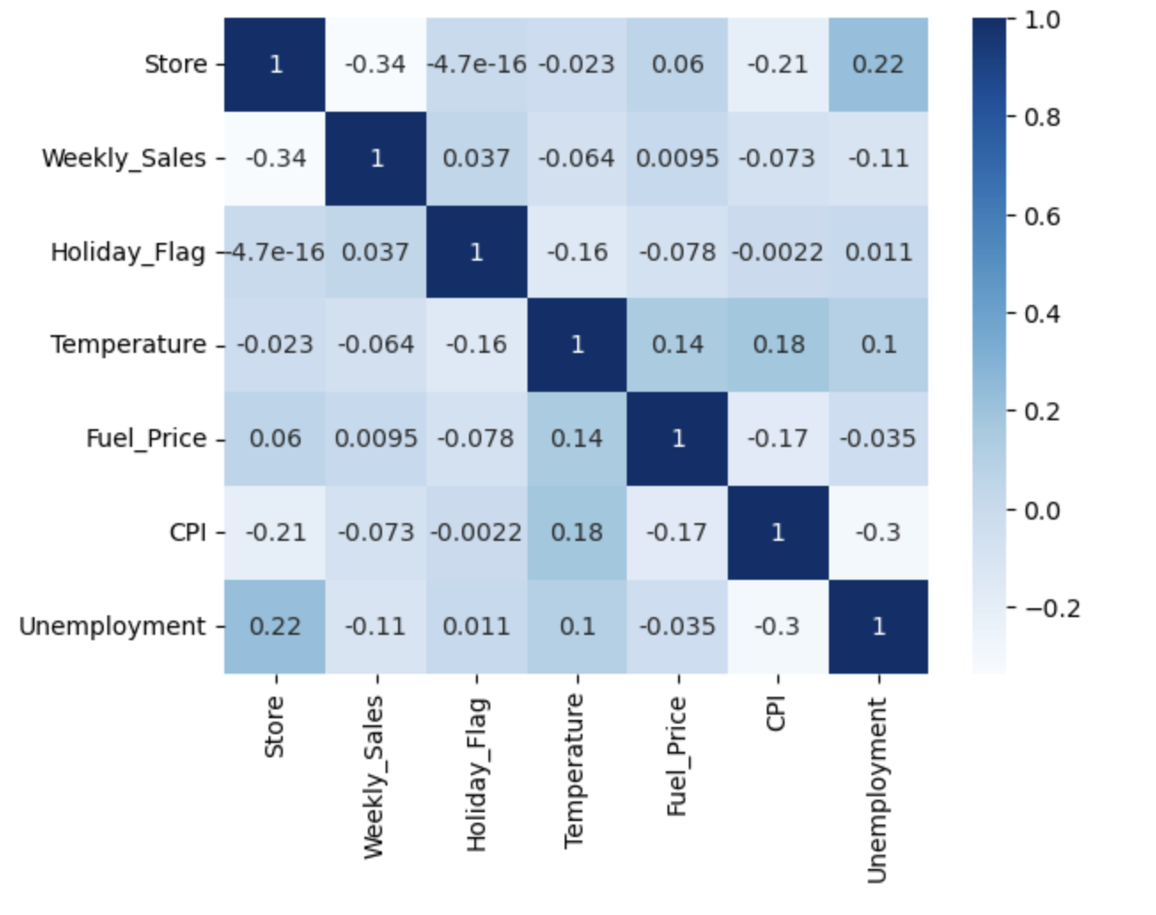

**FEATURE ENGINEERING**

Extracting the date, month and year from the date column

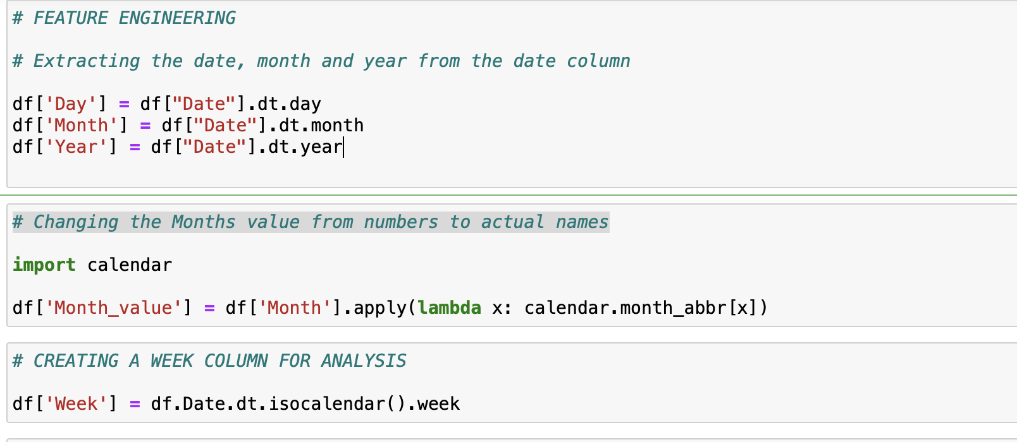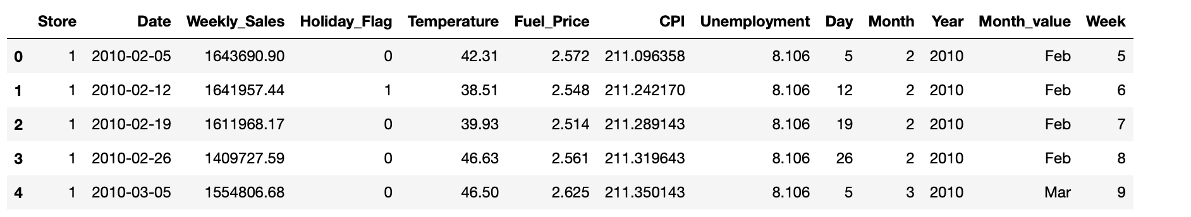

**QUESTIONS TO ANSWER**

1. You are provided with the weekly sales data for their various outlets. Use statistical analysis, EDA, outlier analysis, and handle the missing values to come up with various insights that can give them a clear perspective on the following:
   1. If the weekly sales are affected by the unemployment rate, if yes - which stores are suffering the most?

Unemployment does affect the store sales in the higher index ranges primarily.

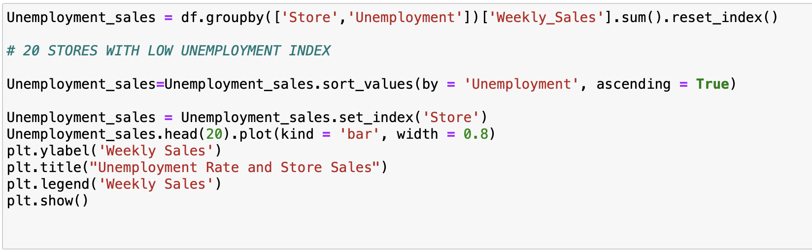

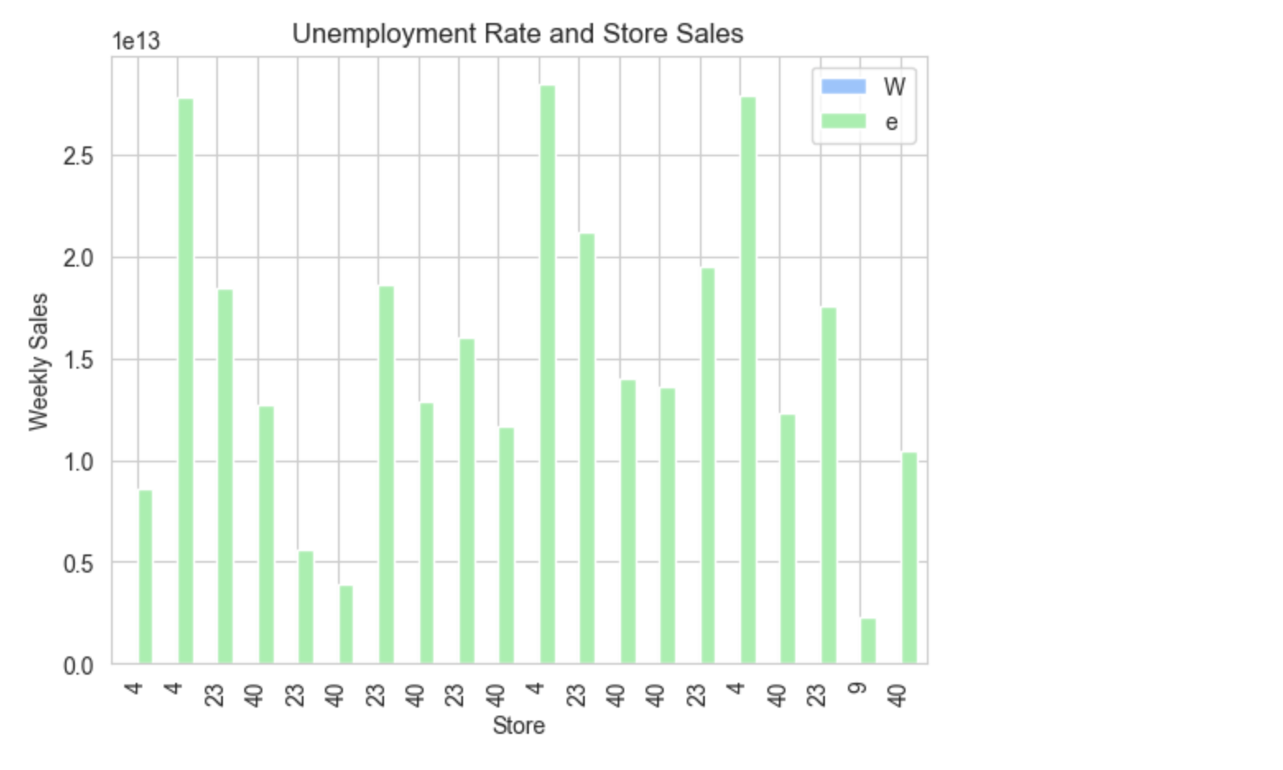

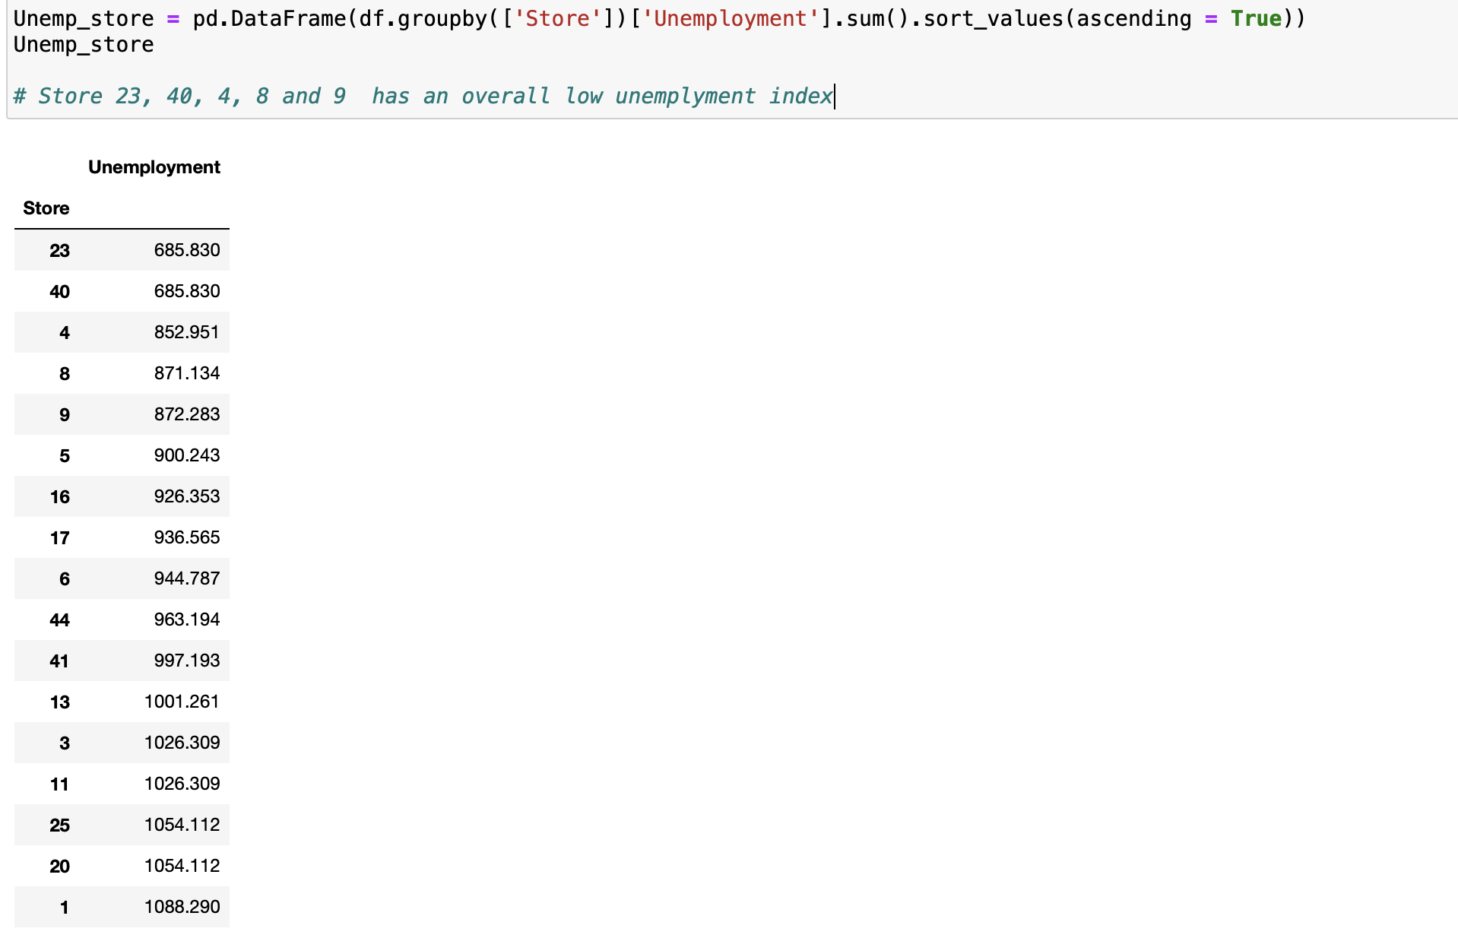

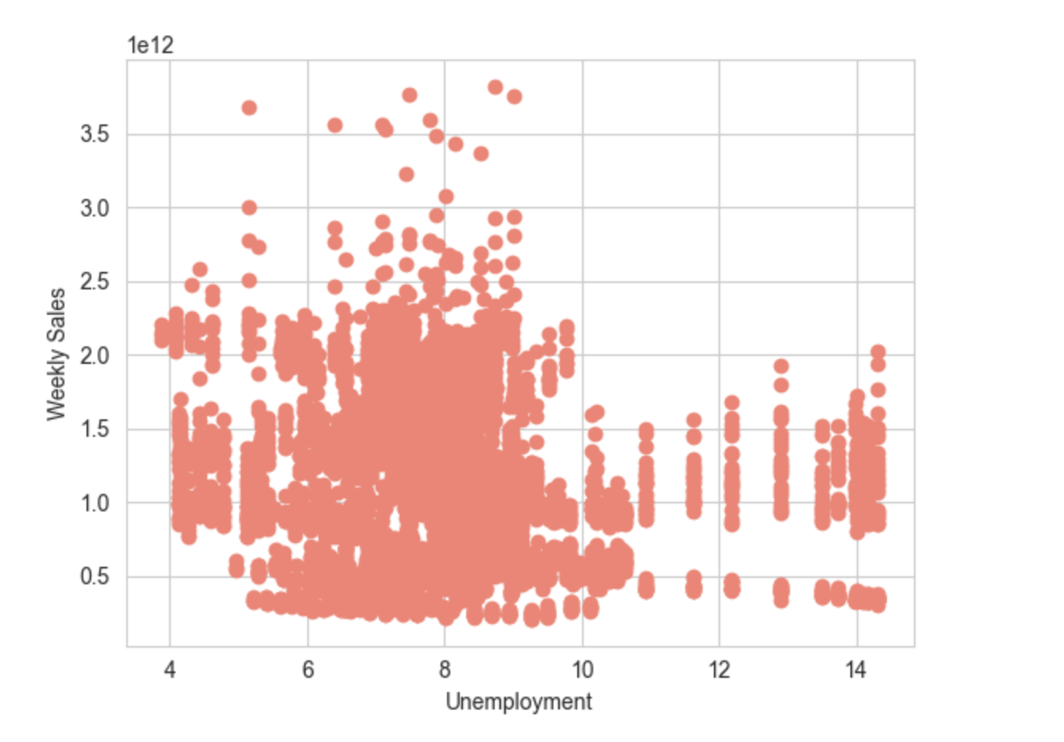

INSIGHTS

* Store 23, 40, 4, 8 and 9 has an overall low unemplyment index and they are ranking multiple times in top 20 ,but do have an overall high sales when compared to ones in the bottom 20
* Unemployment rate when low generally has high sales when compared to the high unemployment index

1. **If the weekly sales show a seasonal trend, when and what could be the reason?**

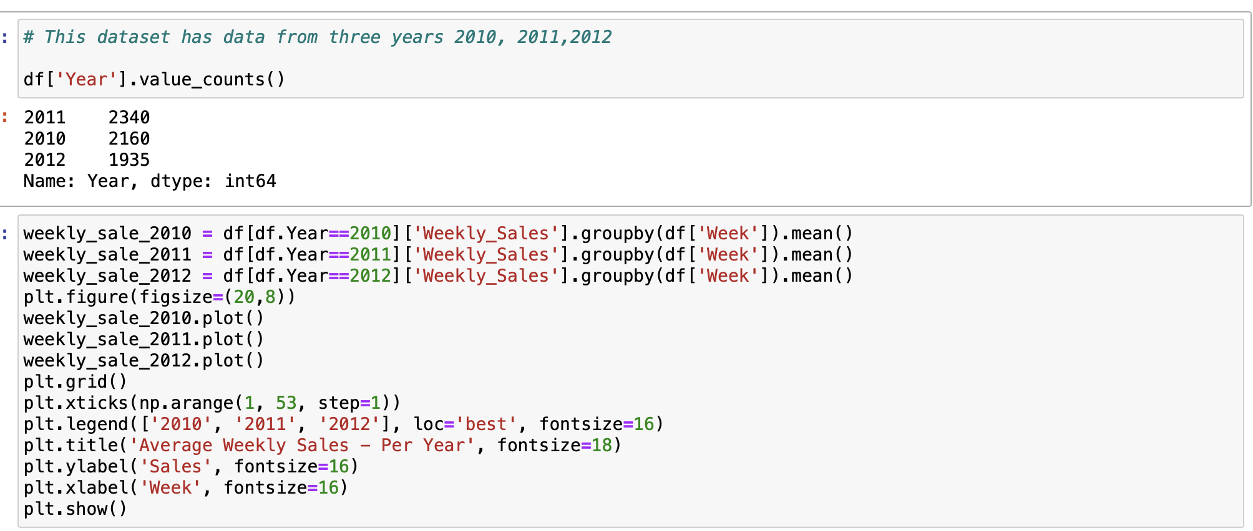

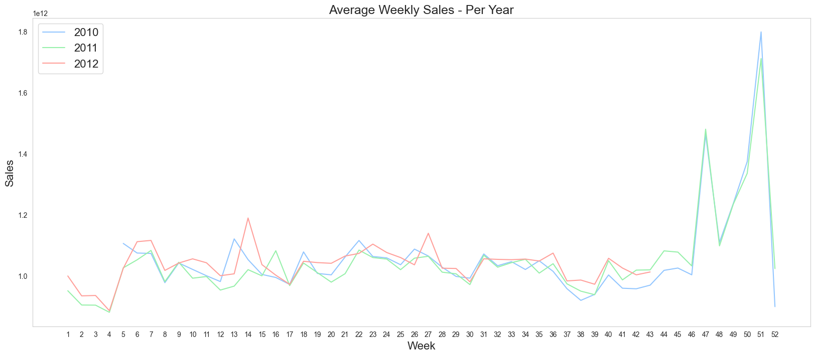

* The sales are highest November and December
* Also peak during easter in April
* Sales are always the lowest in January and again is low in August and September during school holidays.
* This clearly shows the sales are always high during holidays and clearly shows its seasonal data.

1. Does temperature affect the weekly sales in any manner?

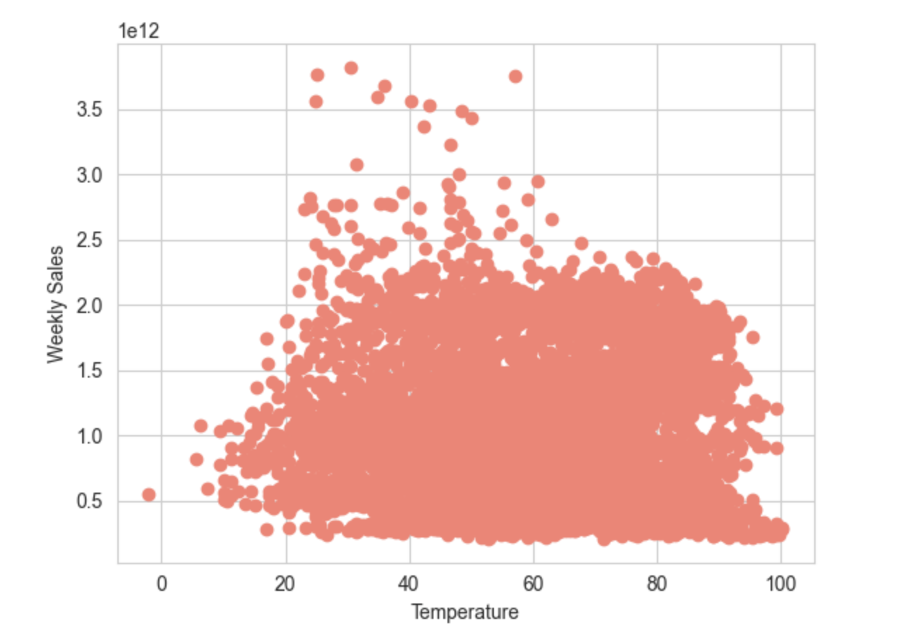

* Sales are low at both extreme temperatures.
* They are most dense between 40-80F.
* In store Sales is very high when the temperatures are more ambient

1. How is the Consumer Price index affecting the weekly sales of various stores?

* The consumer price index does not show much difference in sales.
* It does not make a huge contribution to changes in weekly sales.

1. Top performing stores according to the historical data.



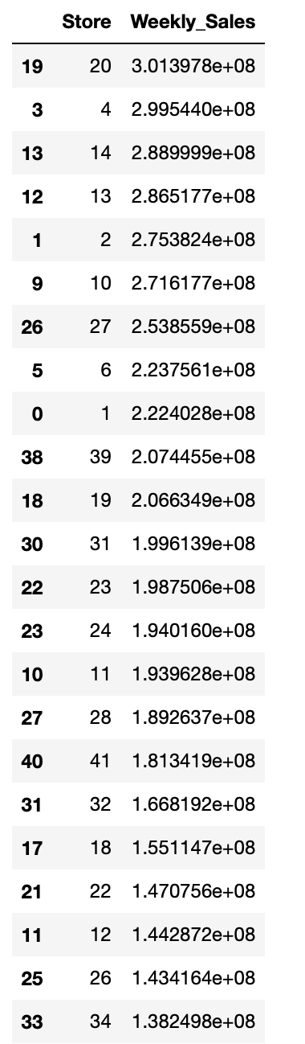

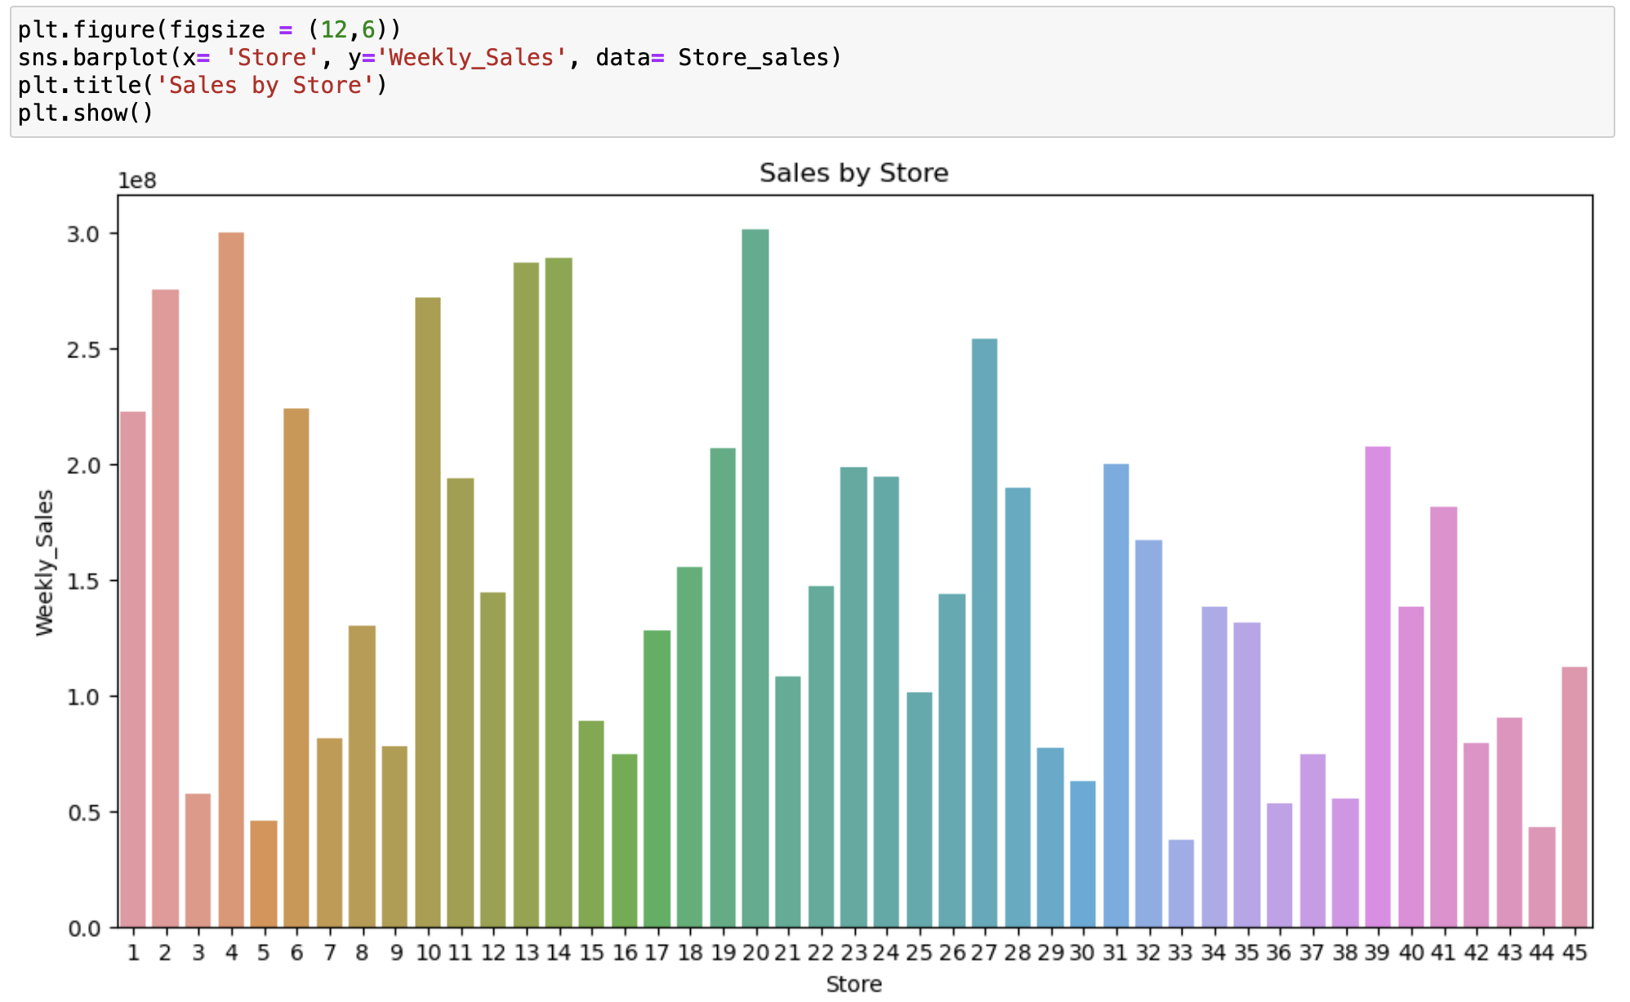

**INSIGHTS**

1. STORE 20 ranks first in sales followed by store 4, 14, 13 and 2

2. Store 38,36, 5, 44 and 33 rank in last 5

**The worst performing store, and how significant is the difference between the highest and lowest performing stores**.

Store 33 has the lowest sales, The difference between the top selling store 20 and store 33

is 264237580.

**WEEKLY SALES**

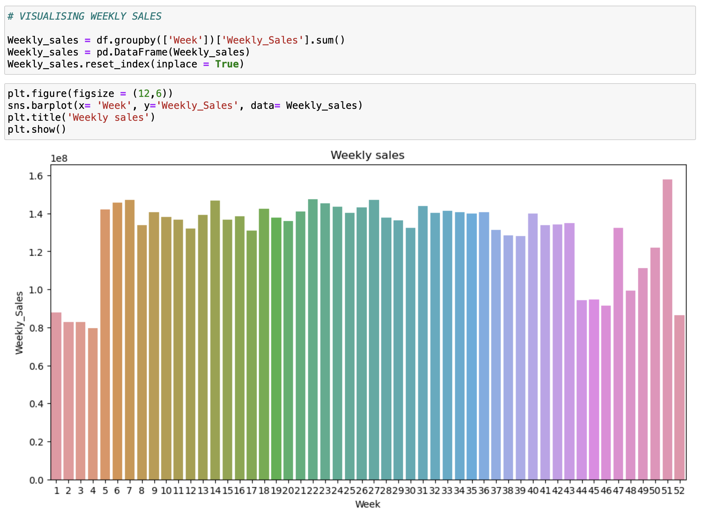

**INSIGHTS**

1. It does show seasonal data where sales are consistently low in certain weeks and consistently average in certain weeks

2. This would make more sense if we can tease out per store data and check for any correlations as different features might affect the sales of different stores

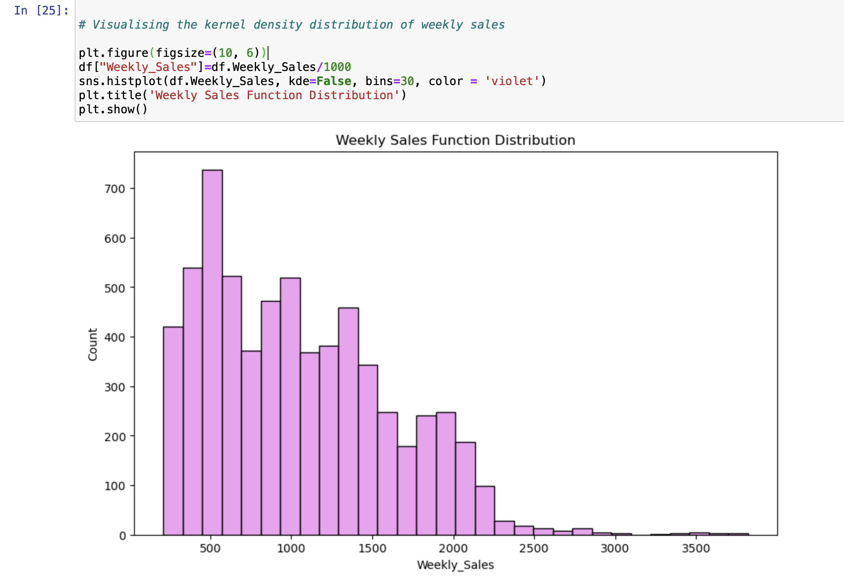

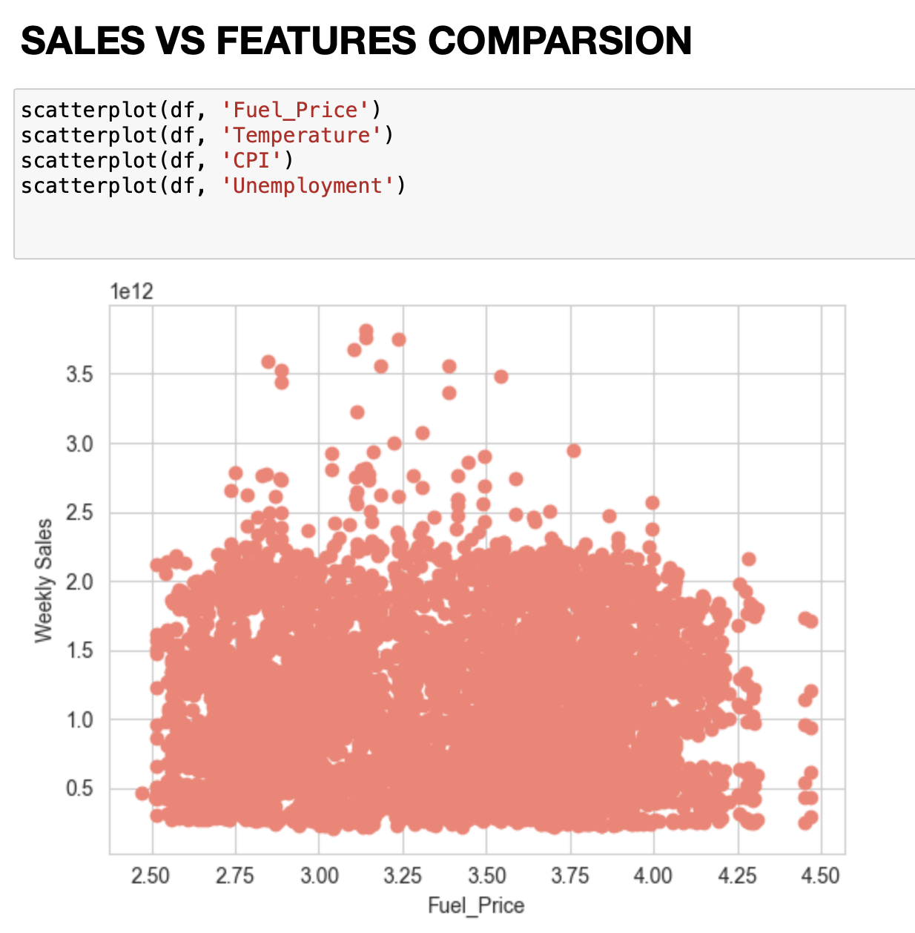 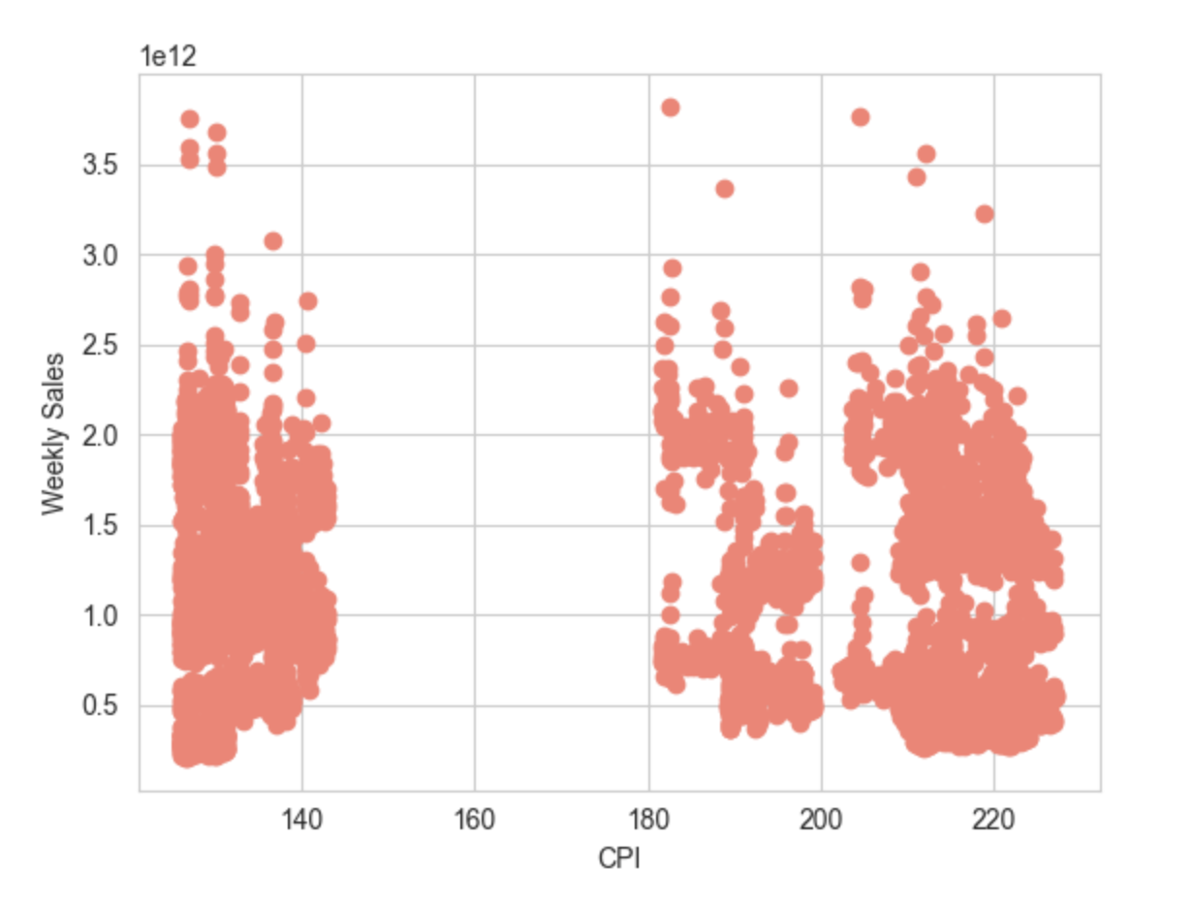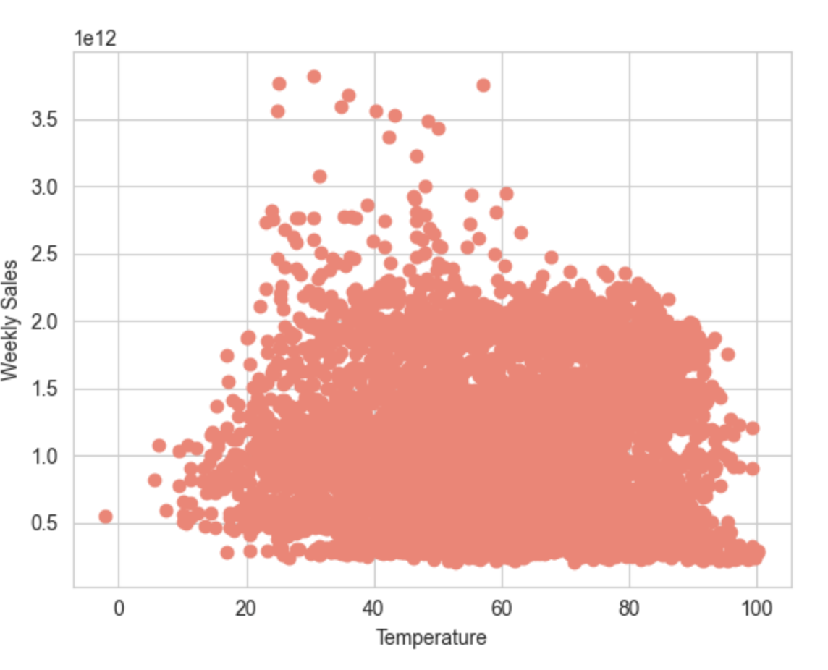

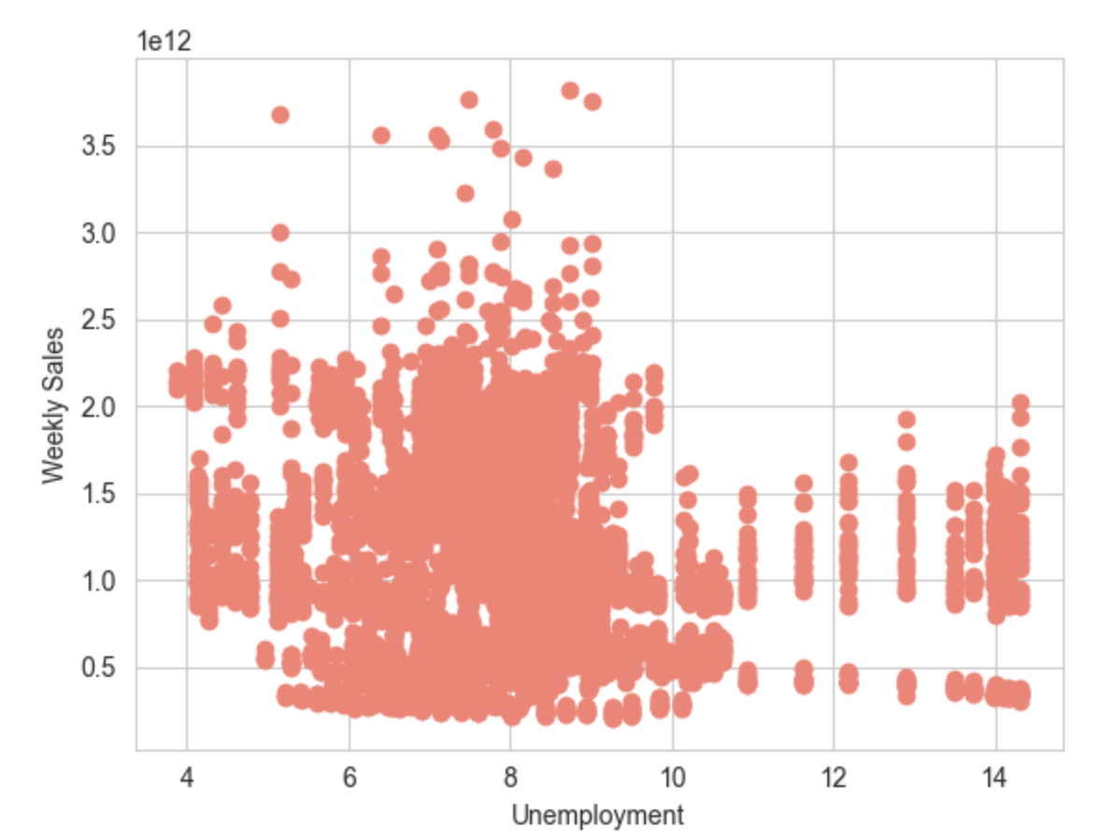

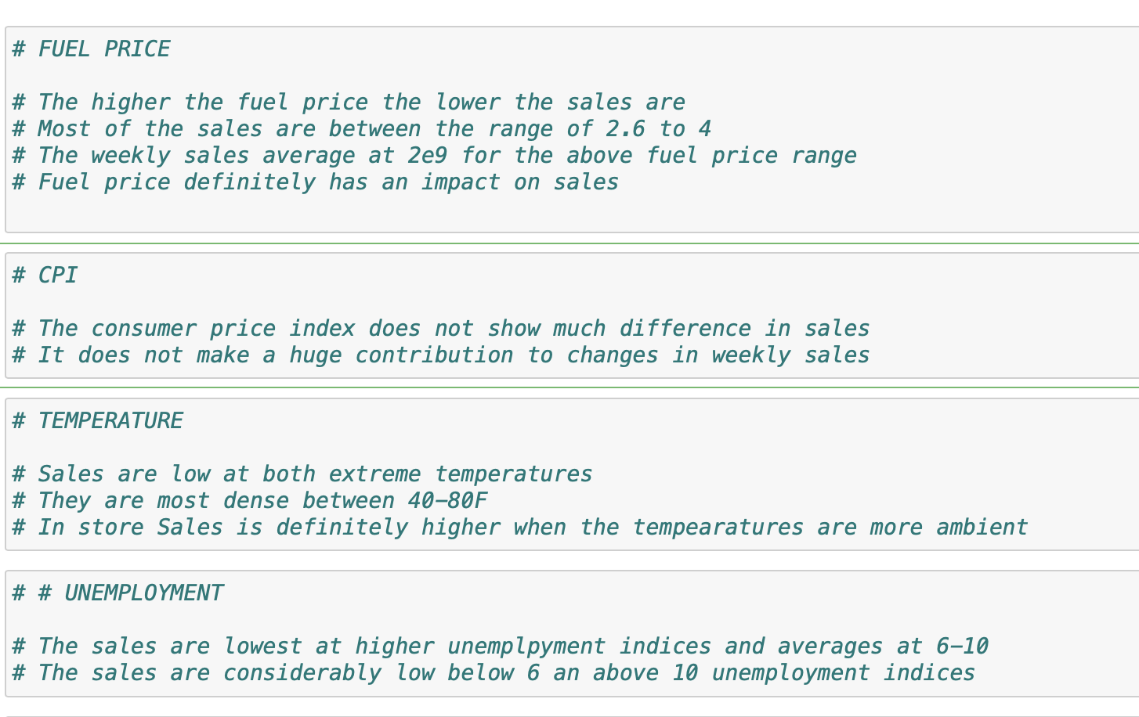

**VISUALISATION OF WEEKLYS SALES ACROSS MONTHS, HOLIDAY FLAG AND STORES**

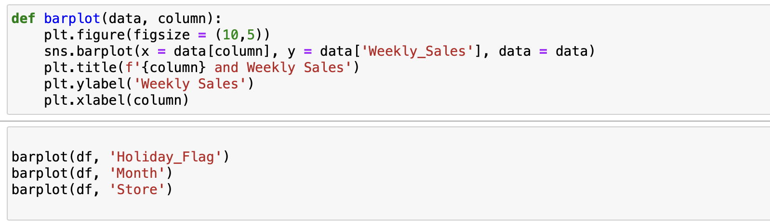

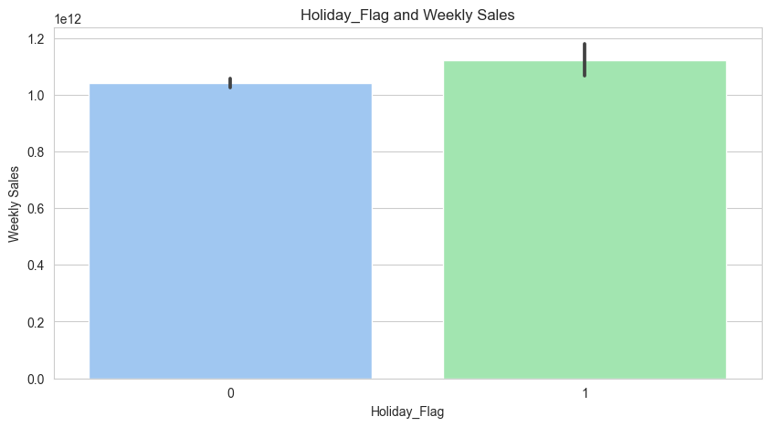

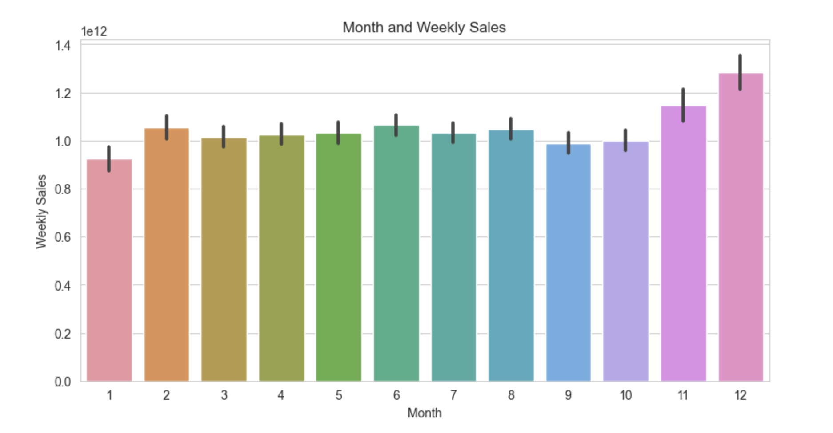

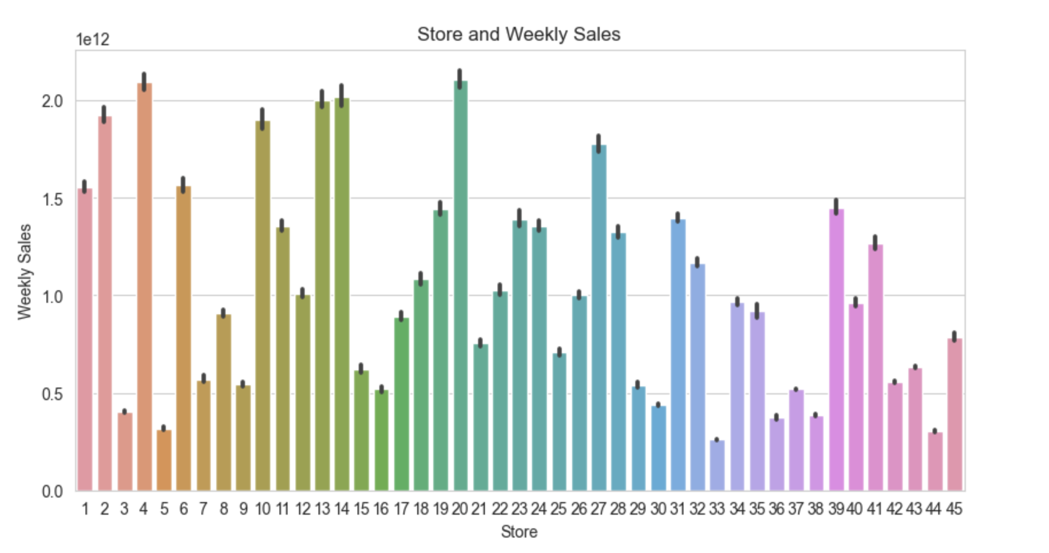

**DATE WISE COMPARISON OF SALES**

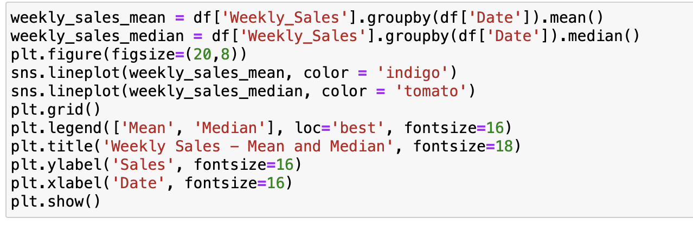

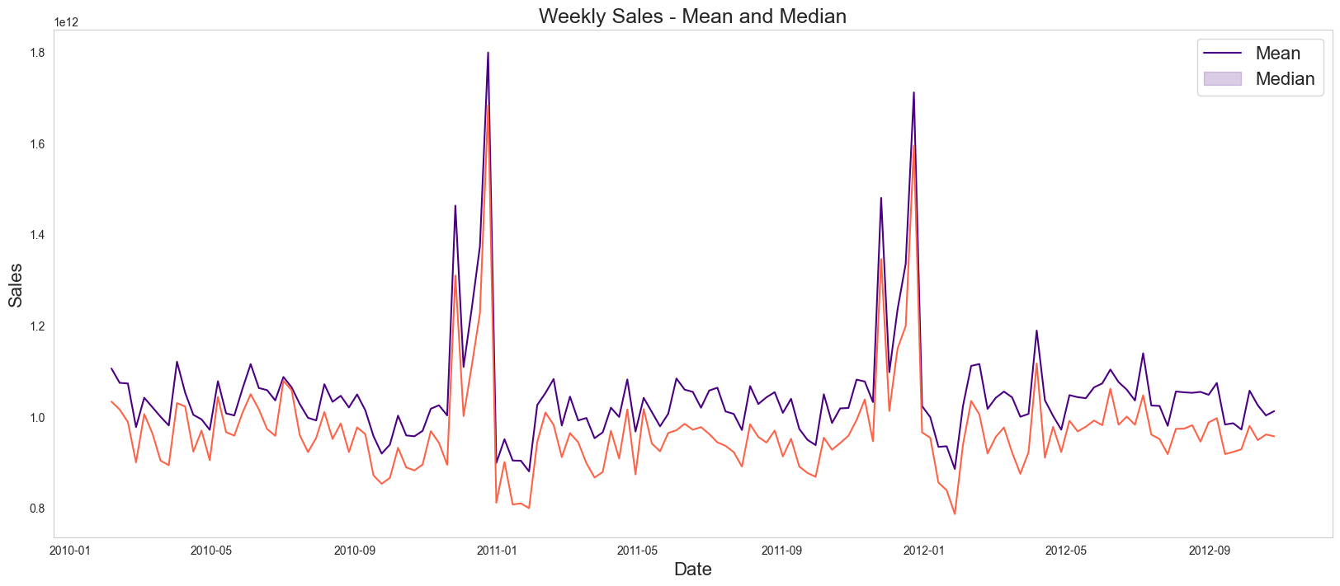

Choosing the Algorithm for the Project

The algorithm that’s being chosen for the project is time series forecasting as we are looking to forecast 3 or more store sales for a period of 12 weeks.

The only algorithm that will allow future forecasting is the time series model.

Assumptions

The following assumptions were made for the project. Since the data is already seasonal, I will doing a seasonal decomposition and looking at future sales prediction.

Model Evaluation and Technique

I am using prophet machine learning model for the time series forecasting as this is a very recent time series forecasting library launched by Meta.

Prophet is a procedure for forecasting time series data based on an additive model where non-linear trends are fit with yearly, weekly, and daily seasonality, plus holiday effects. It works best with time series that have strong seasonal effects and several seasons of historical data. Prophet is robust to missing data and shifts in the trend, and typically handles outliers well.

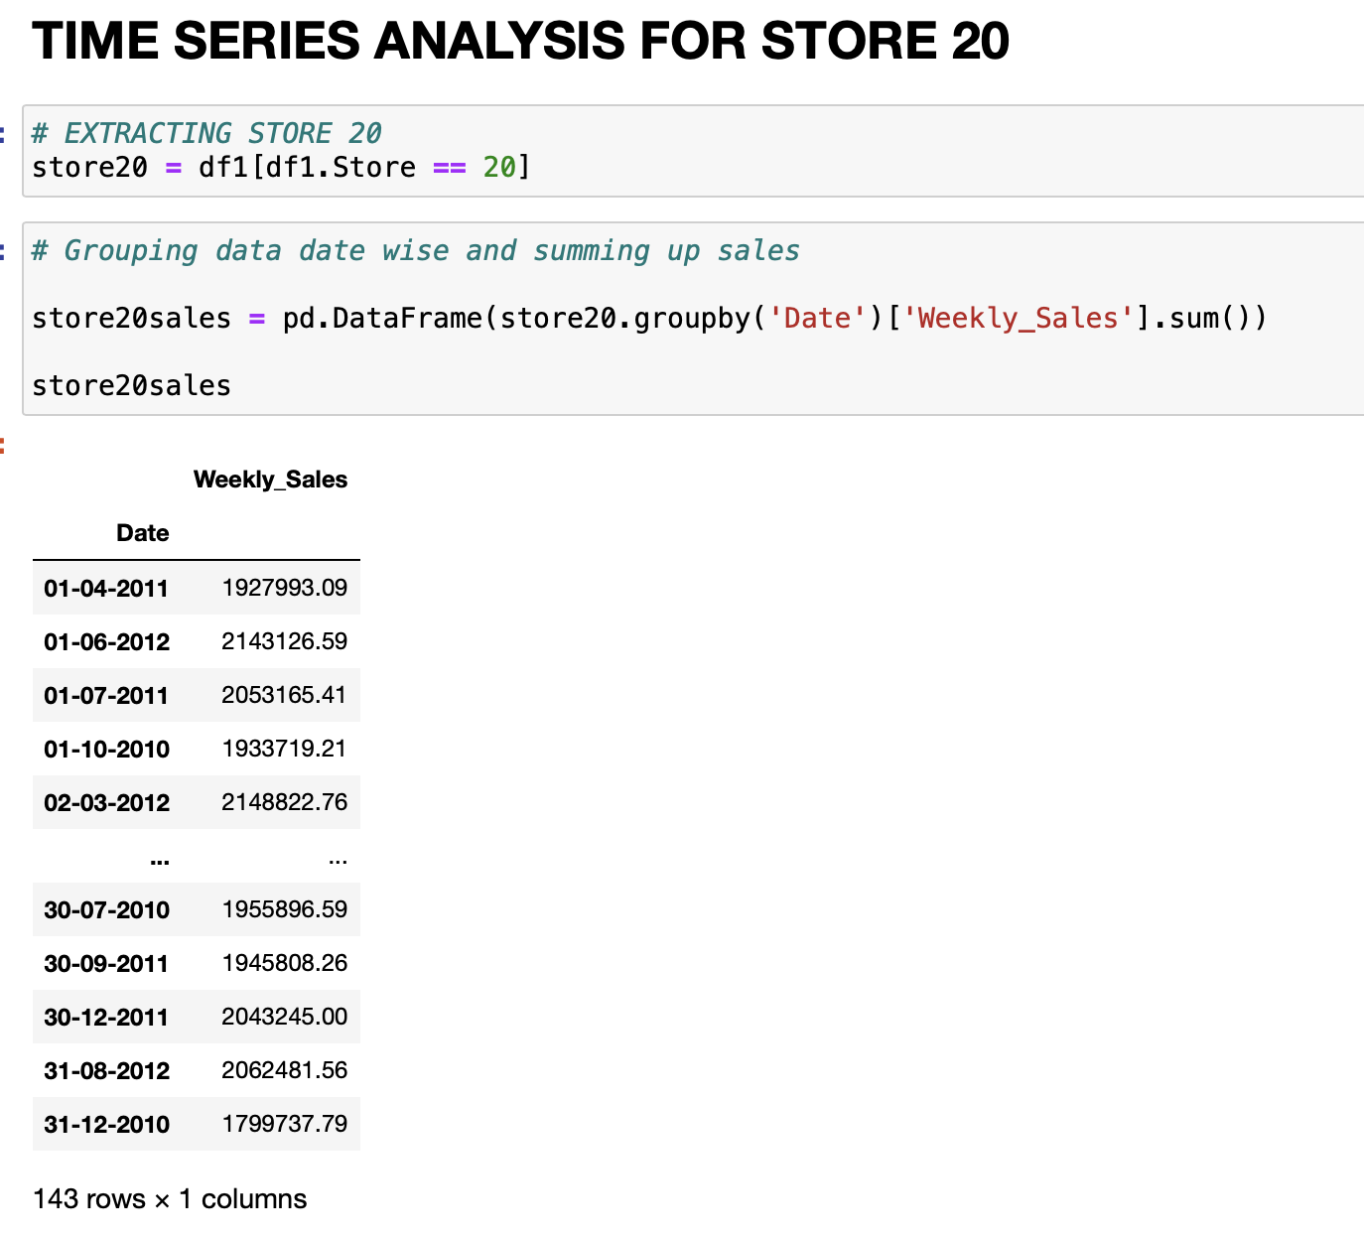

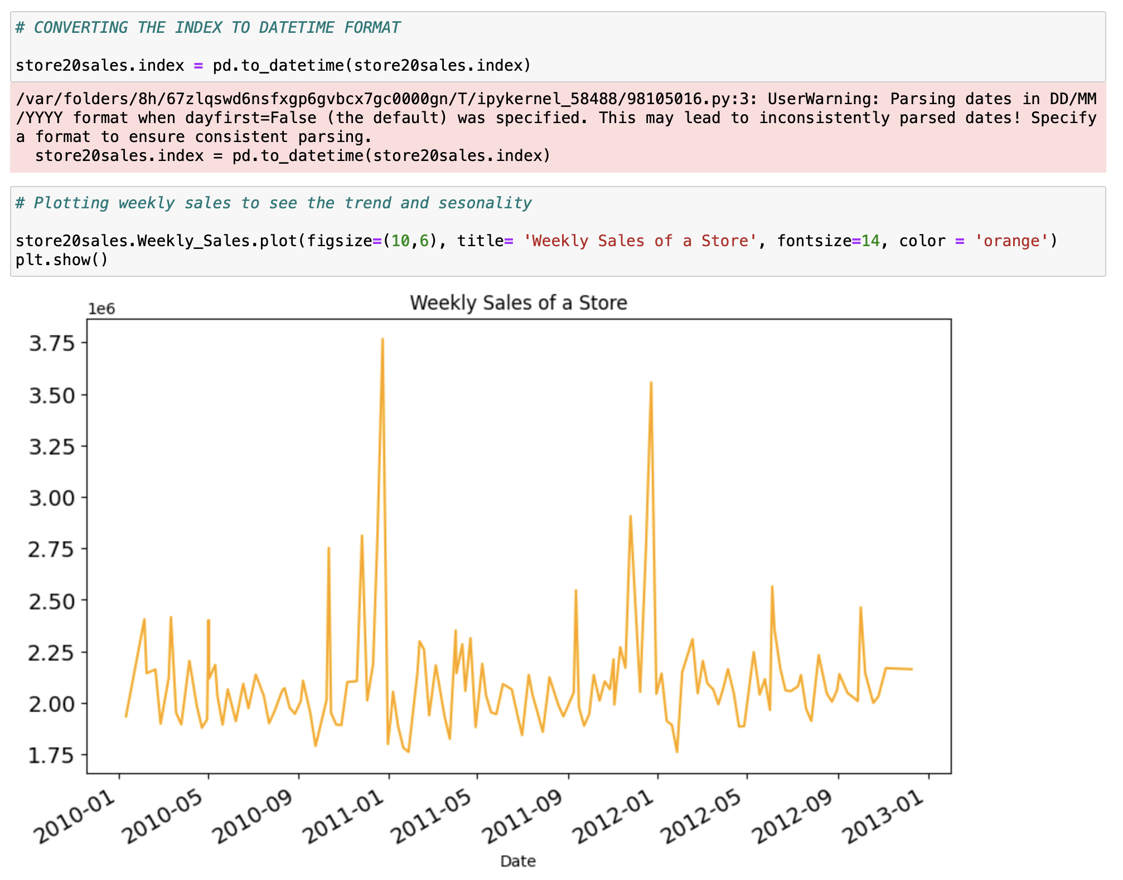

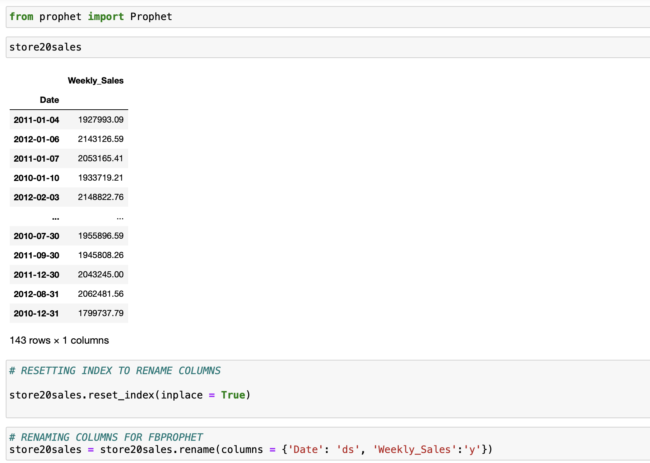

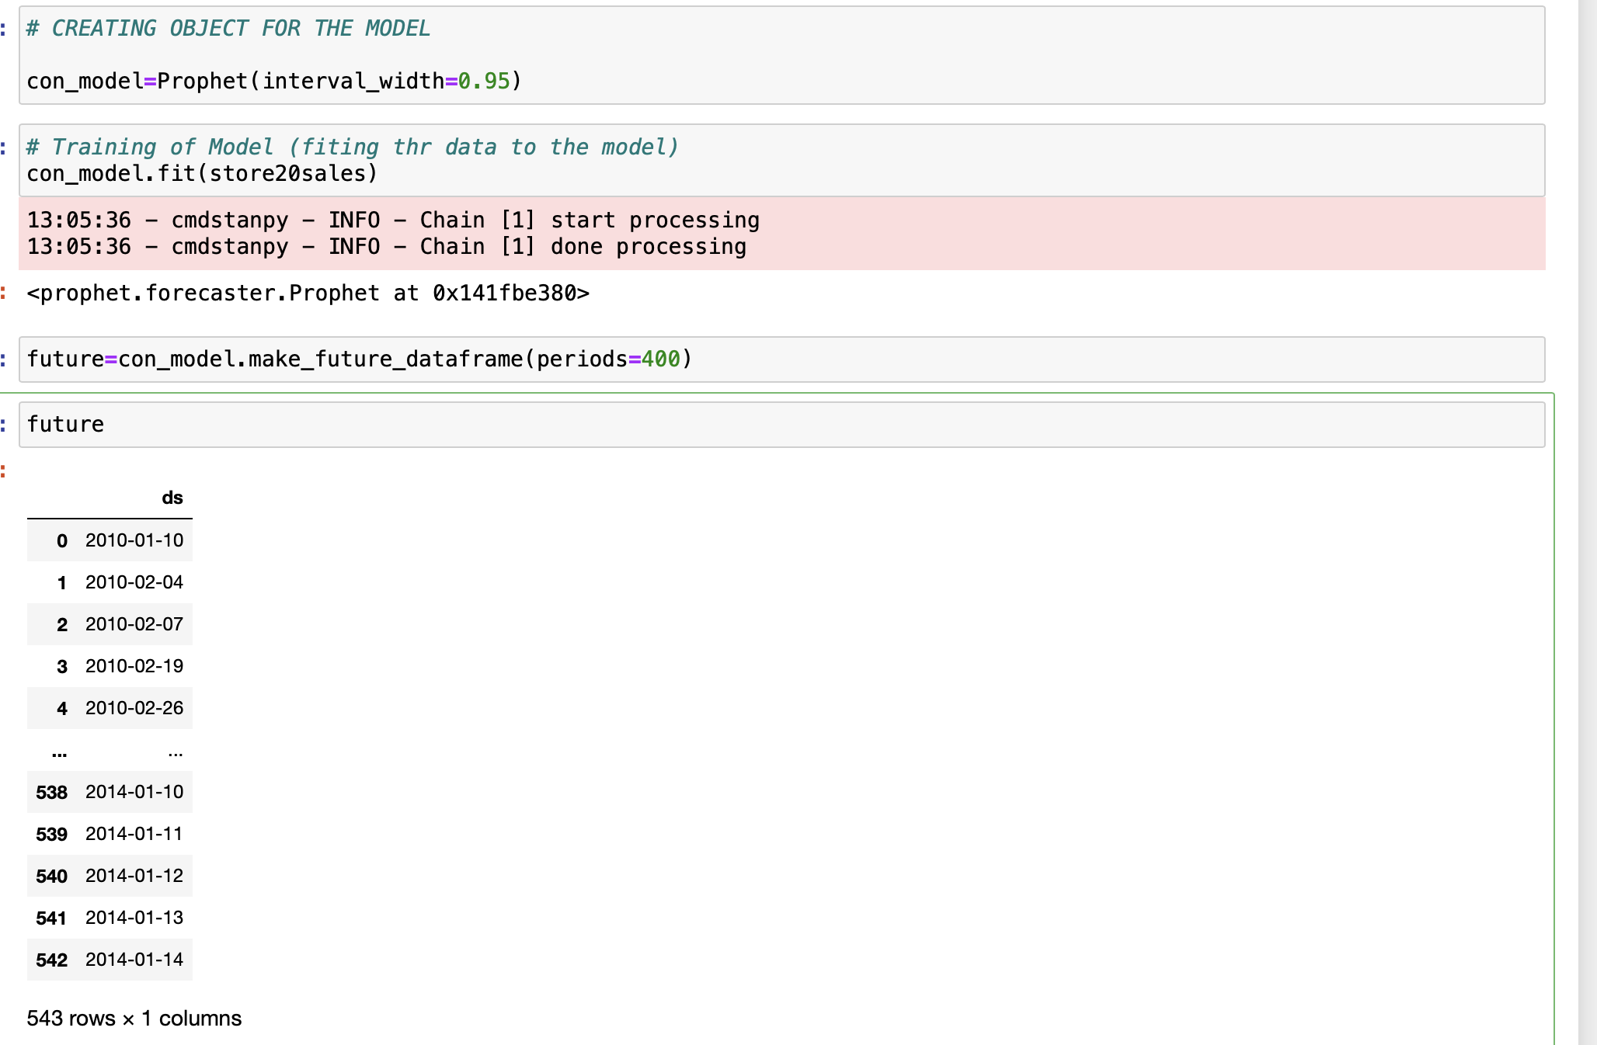

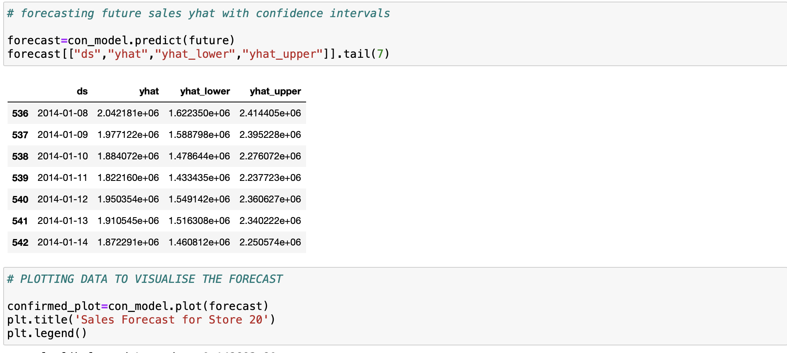

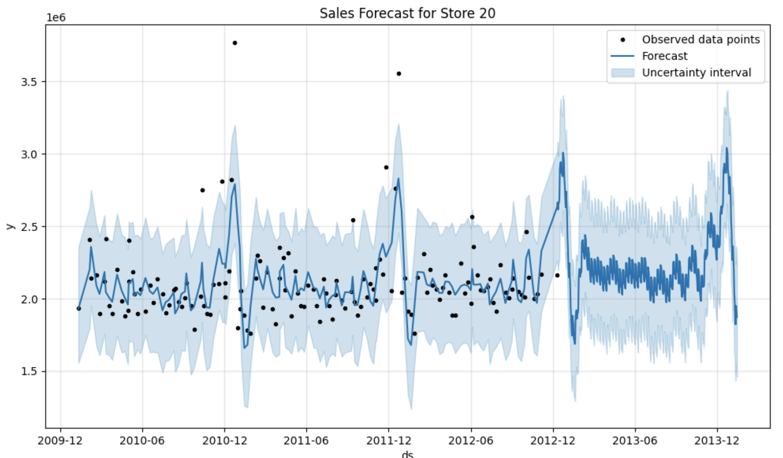

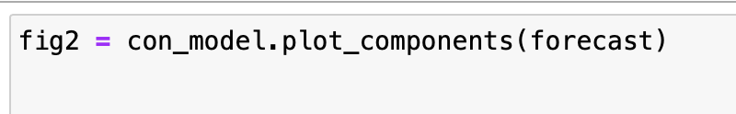

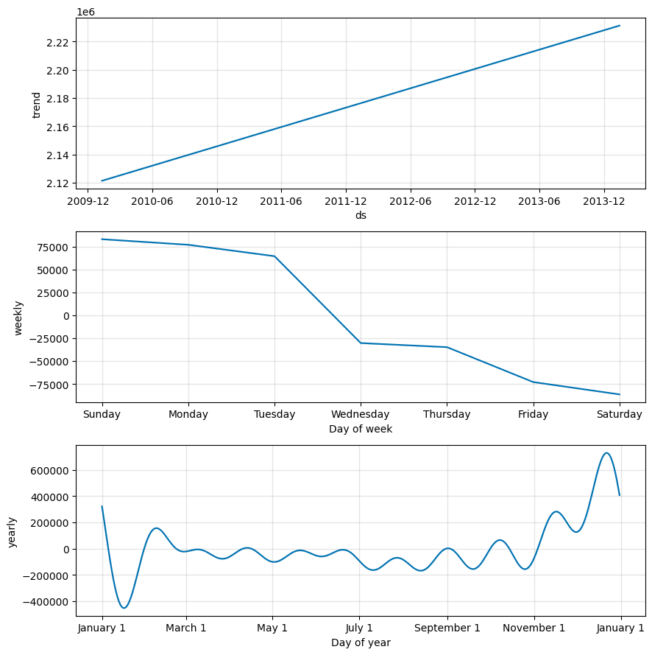

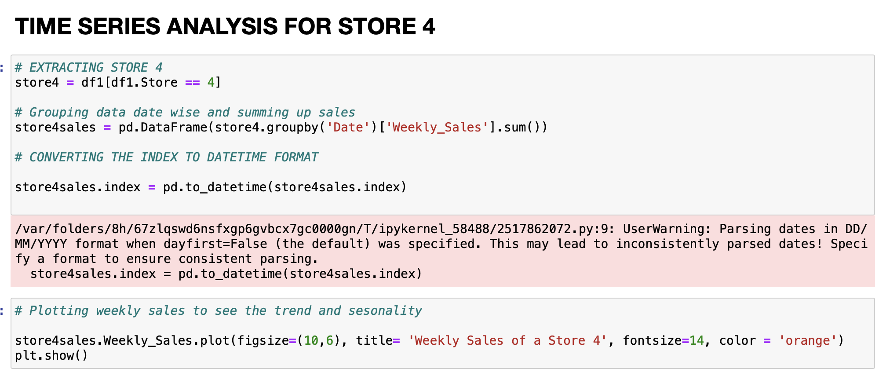

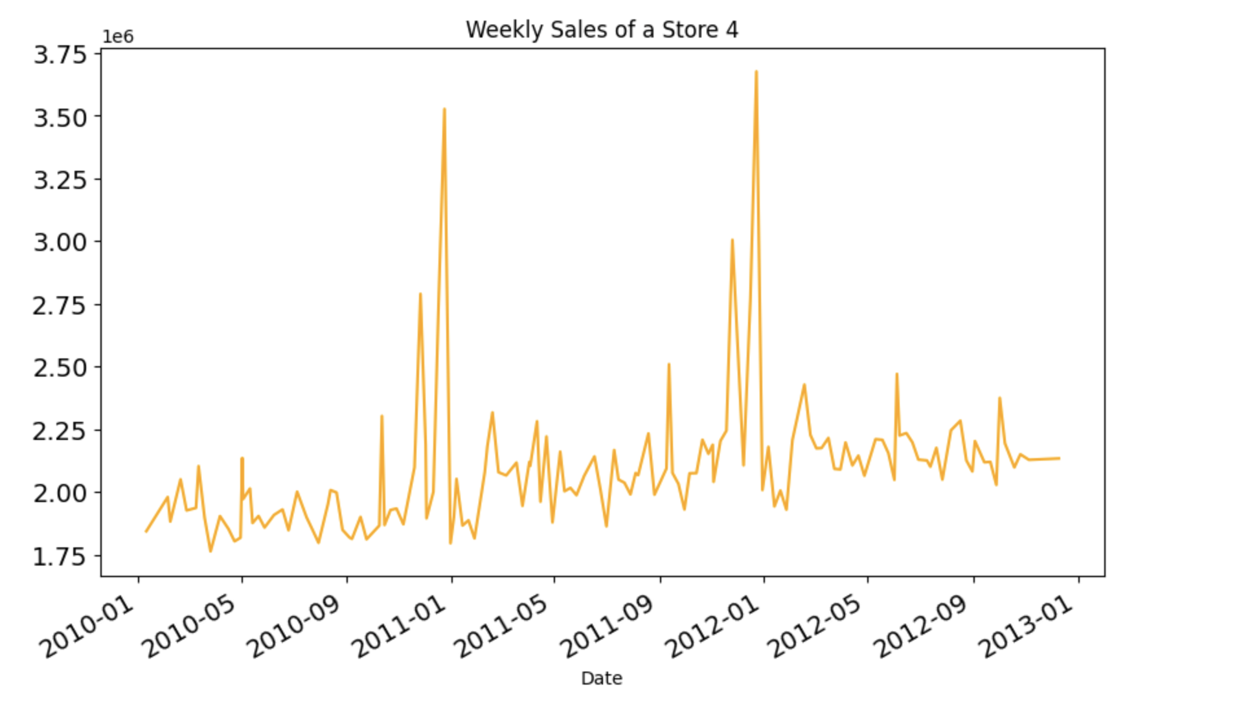

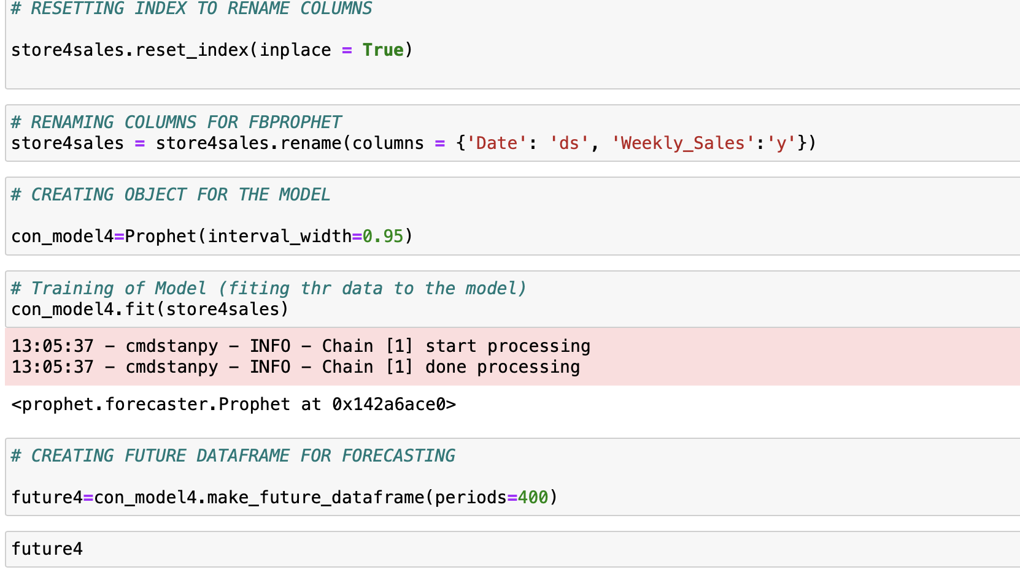

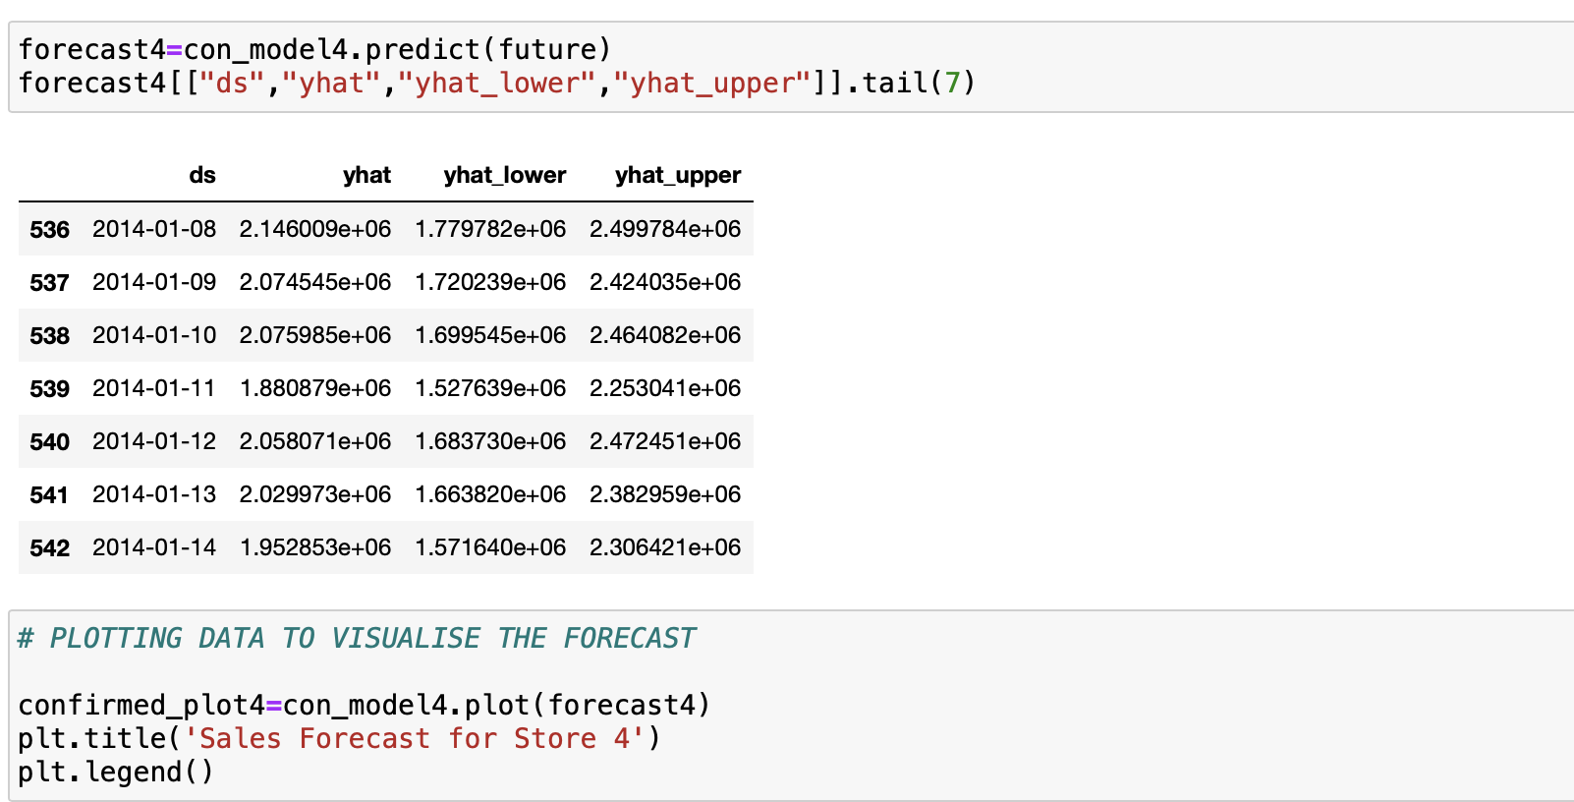

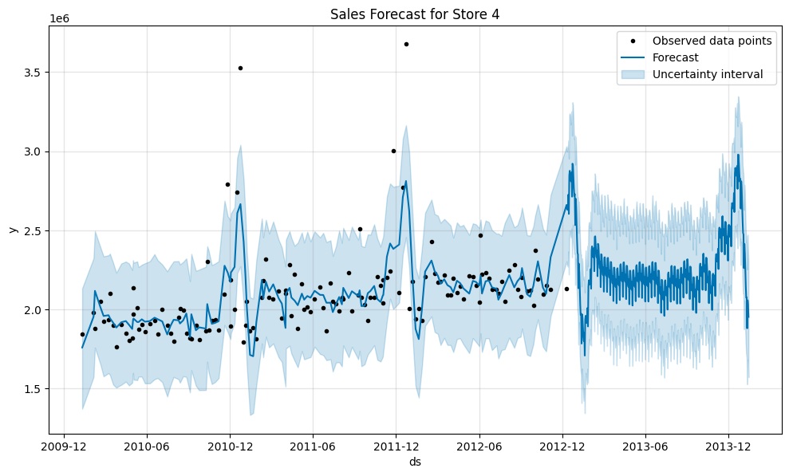

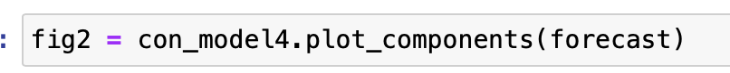

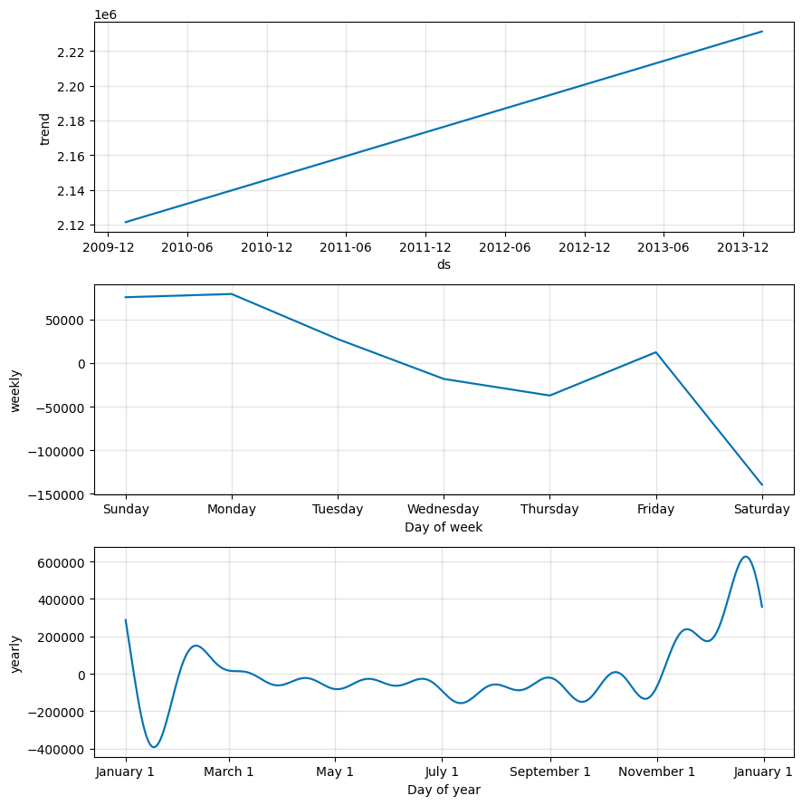

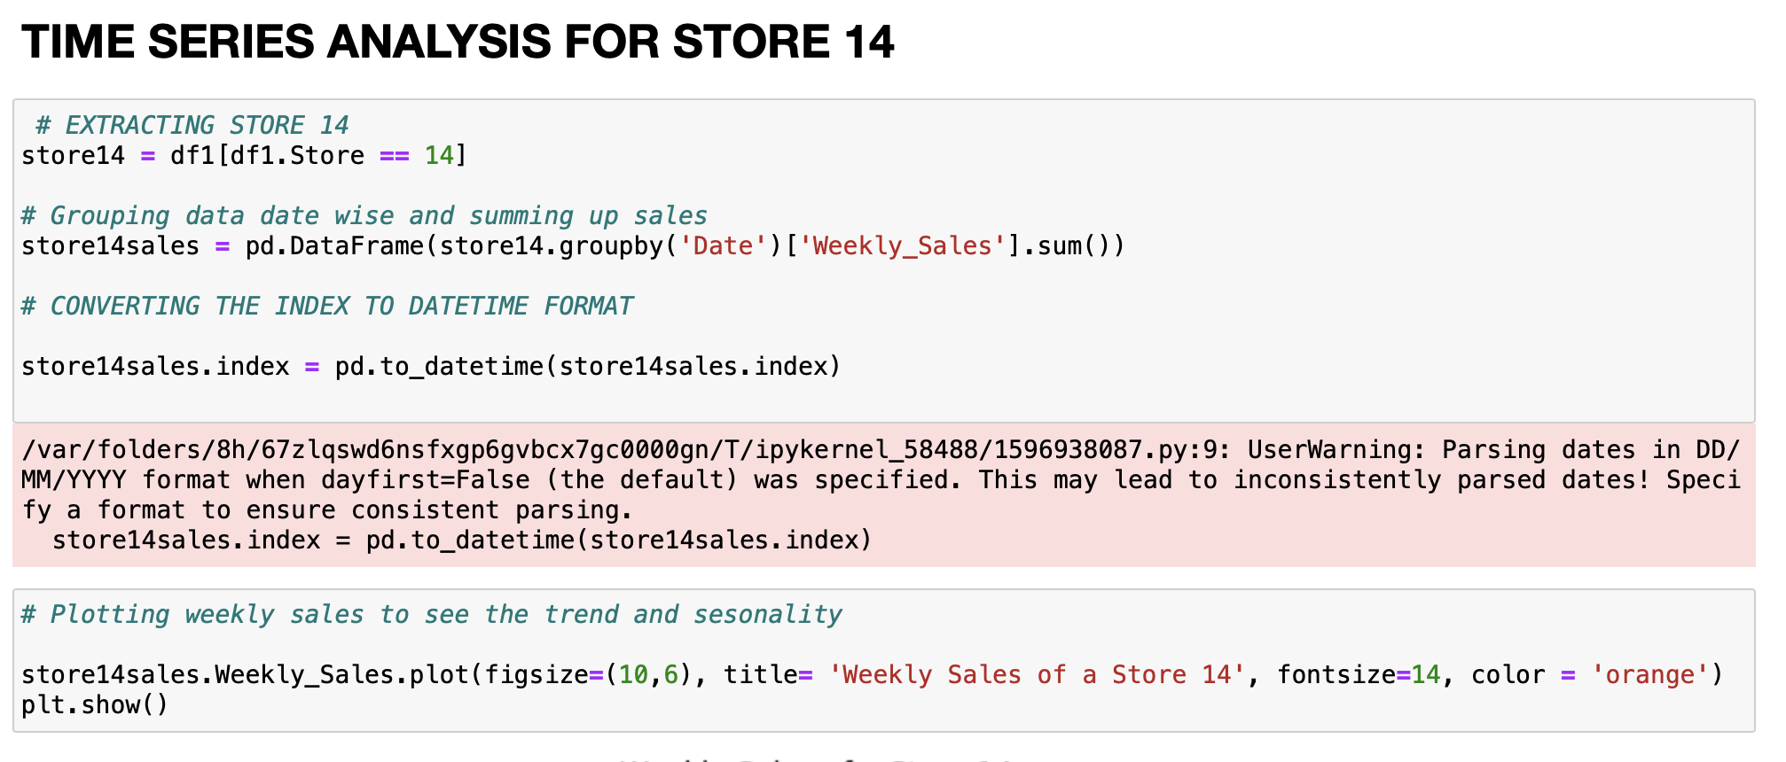

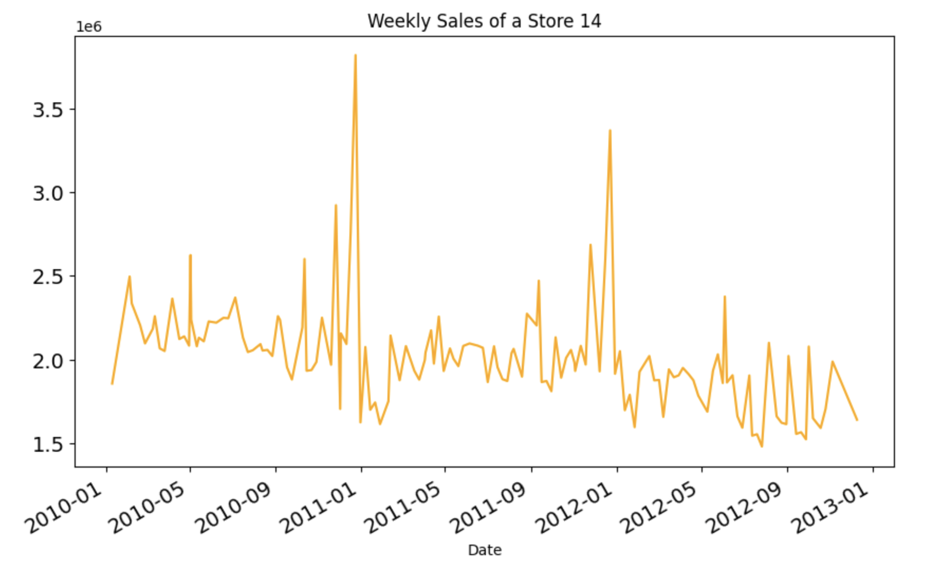

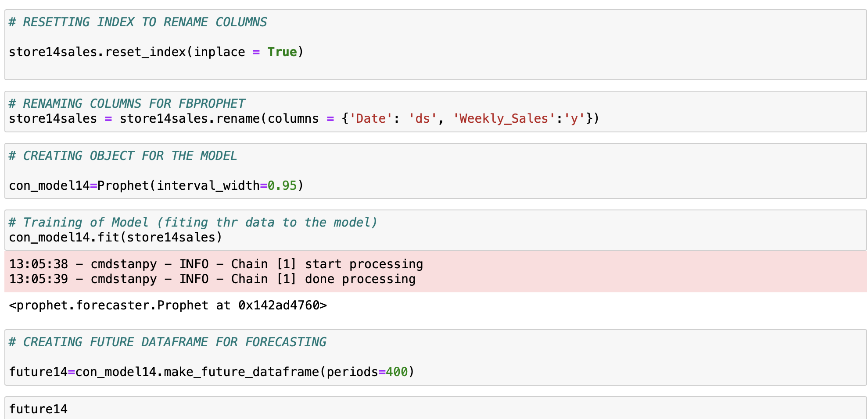

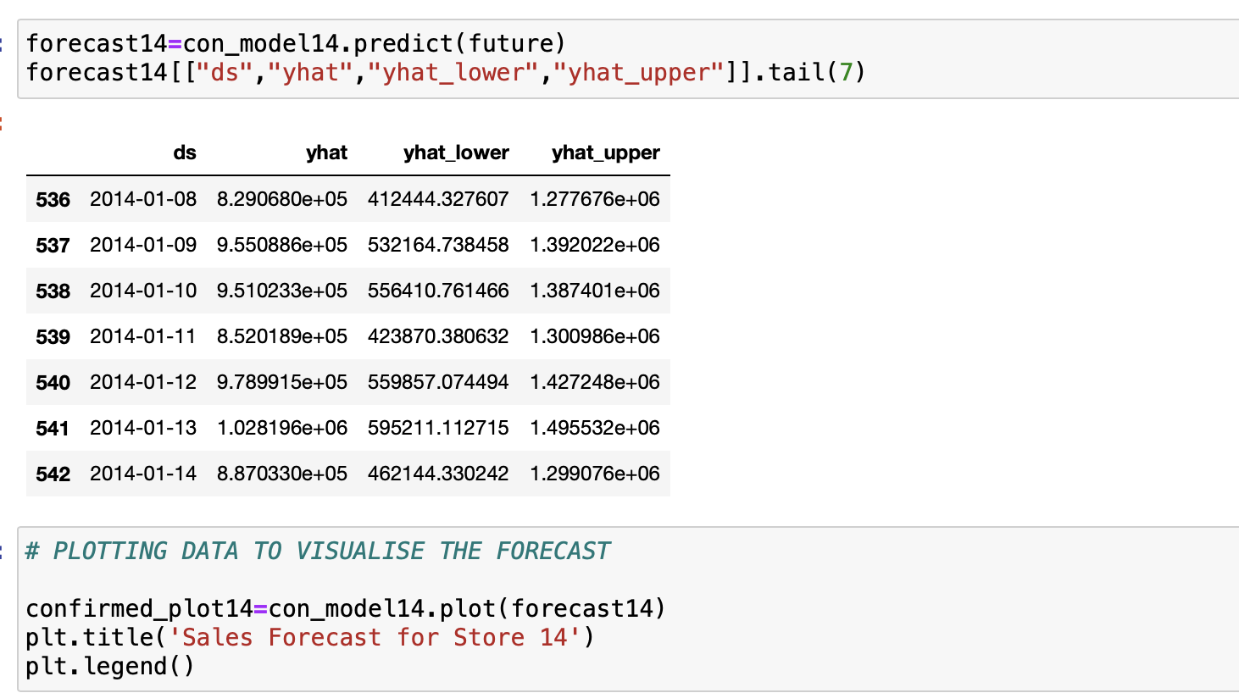

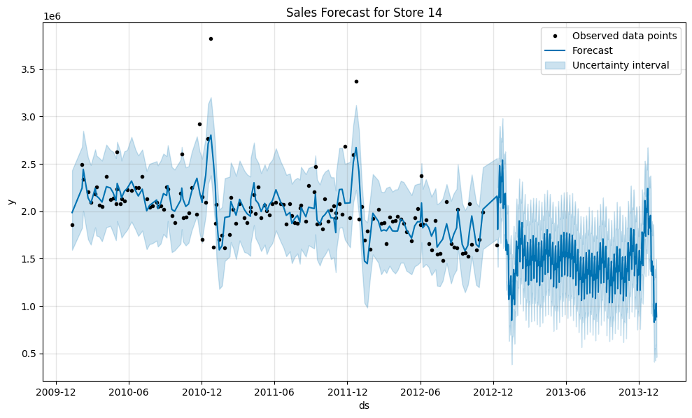

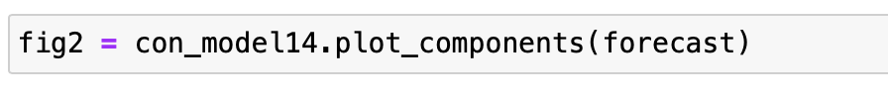

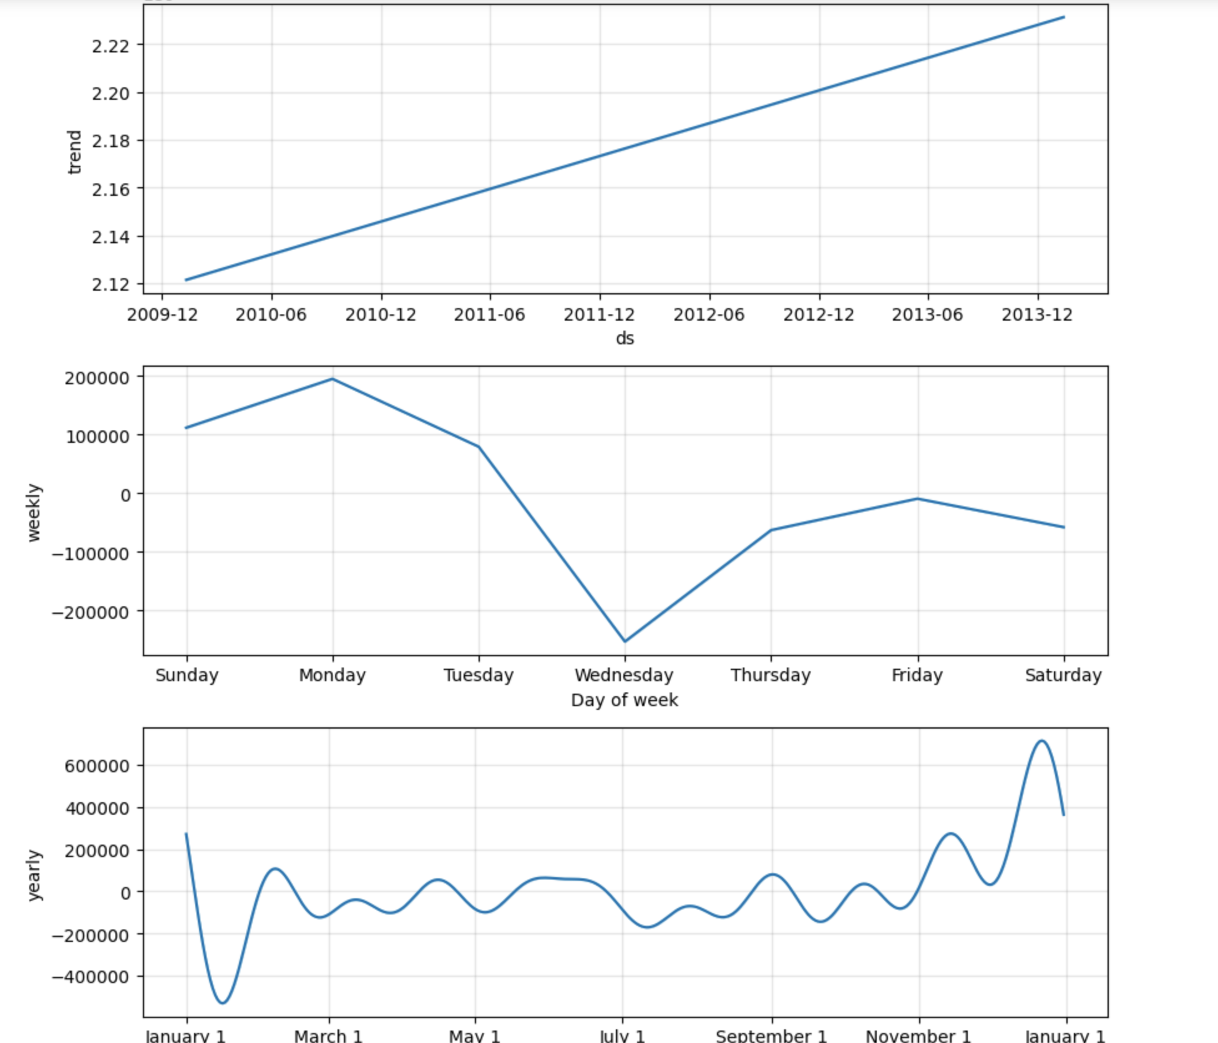

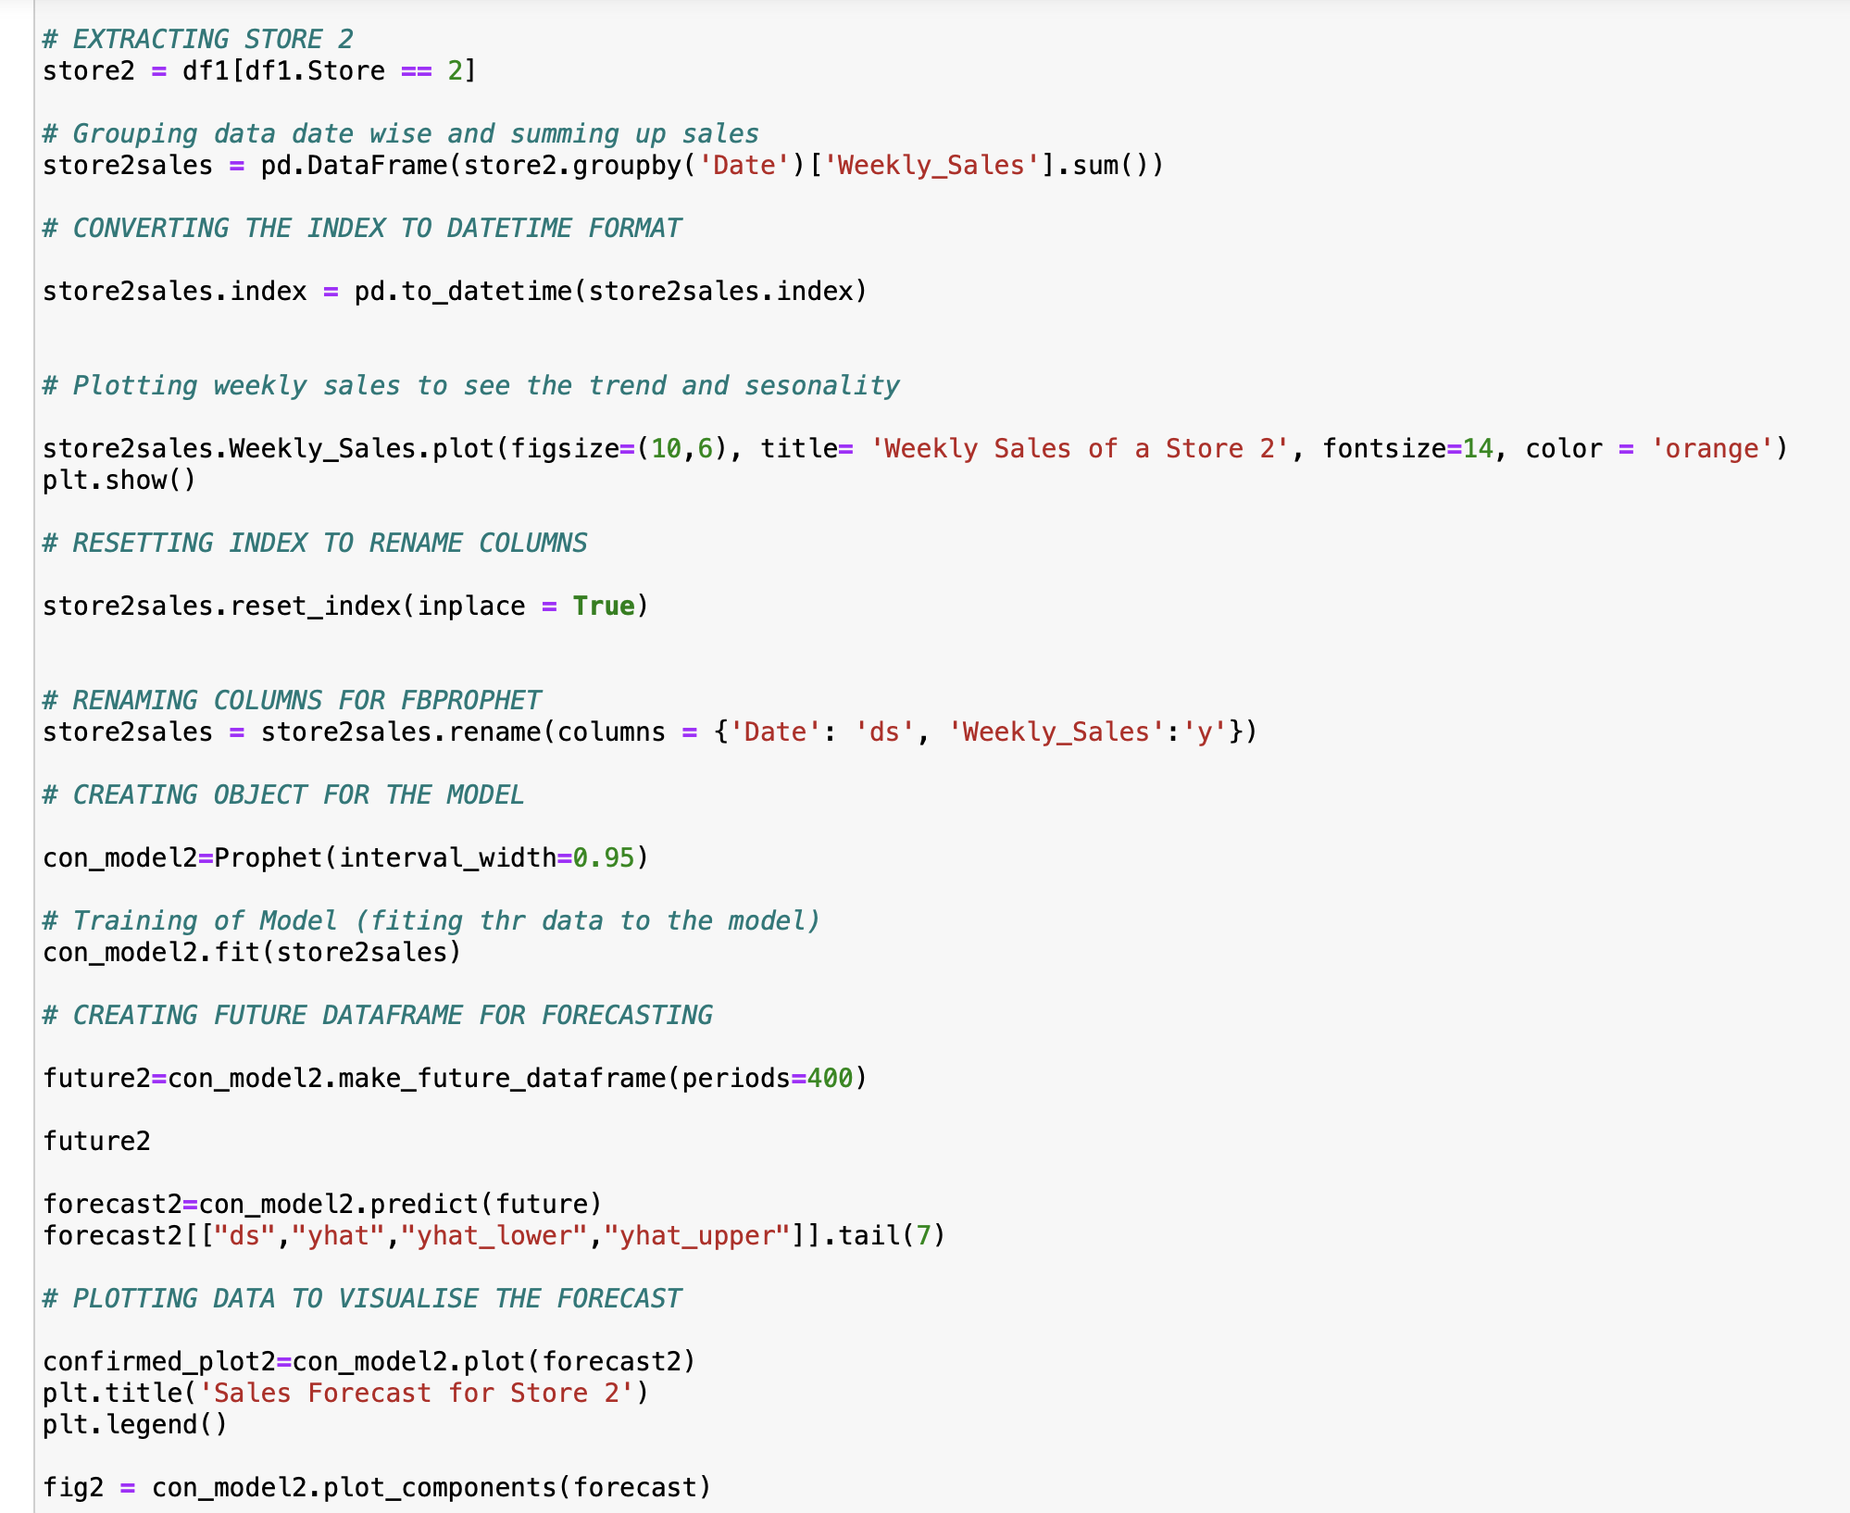

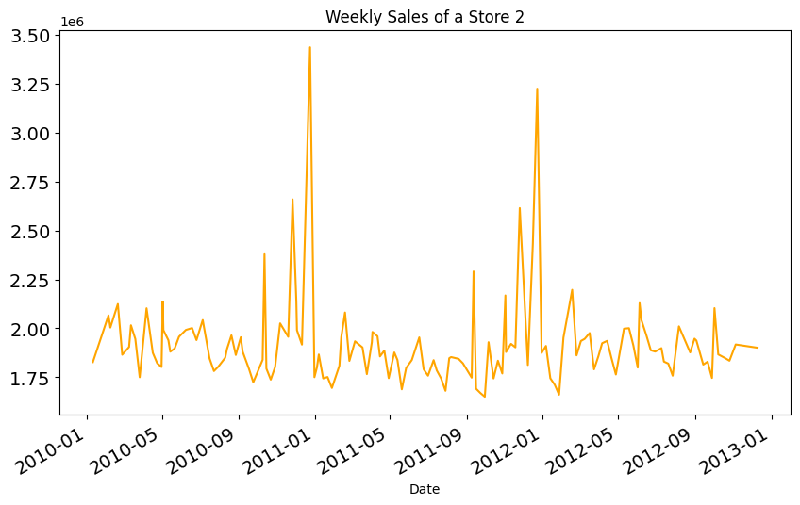

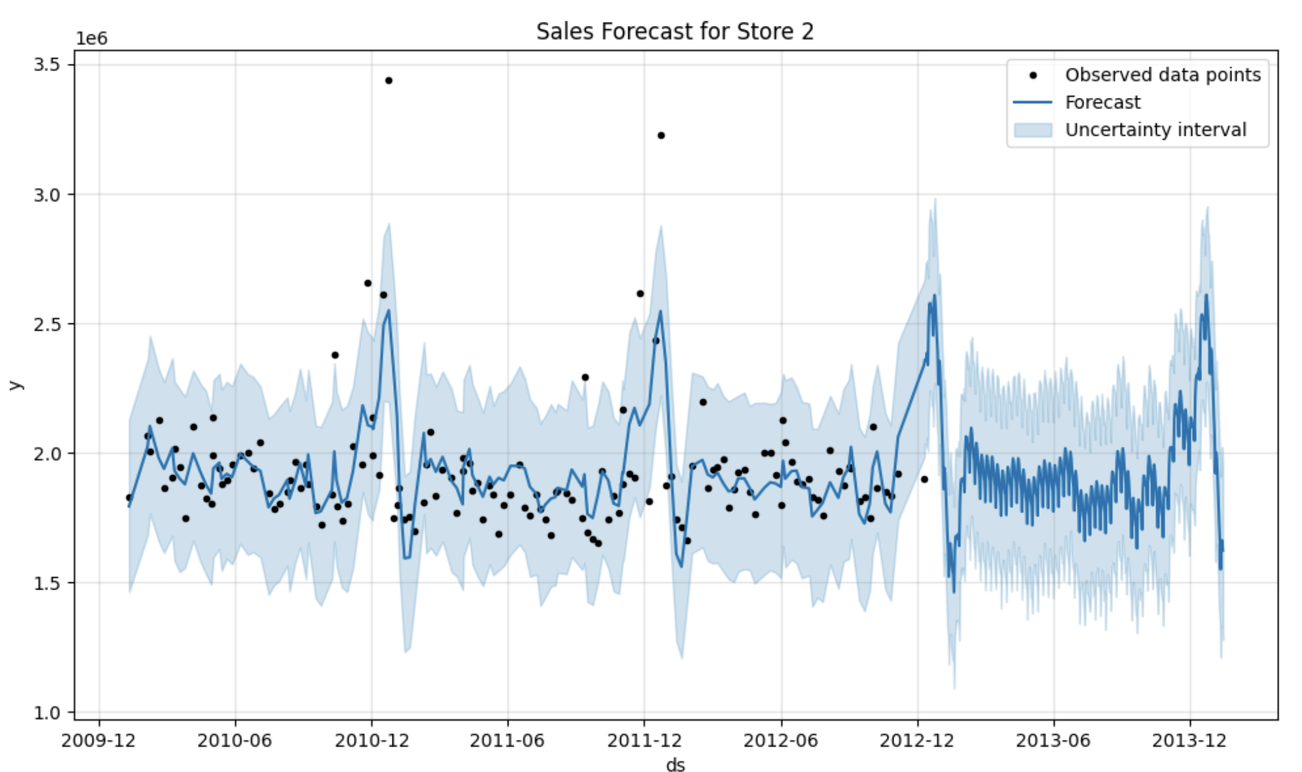

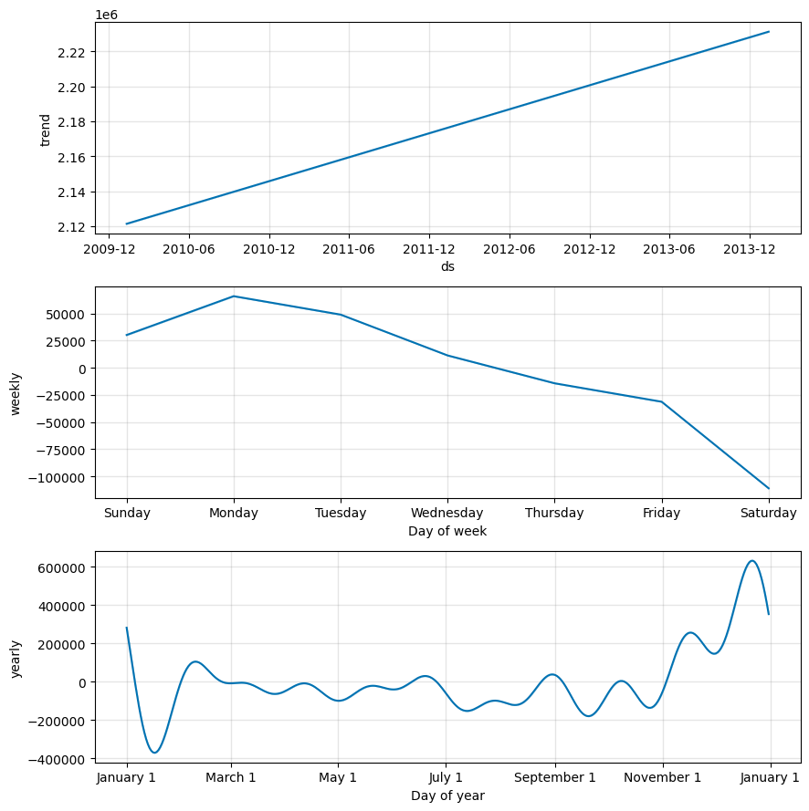



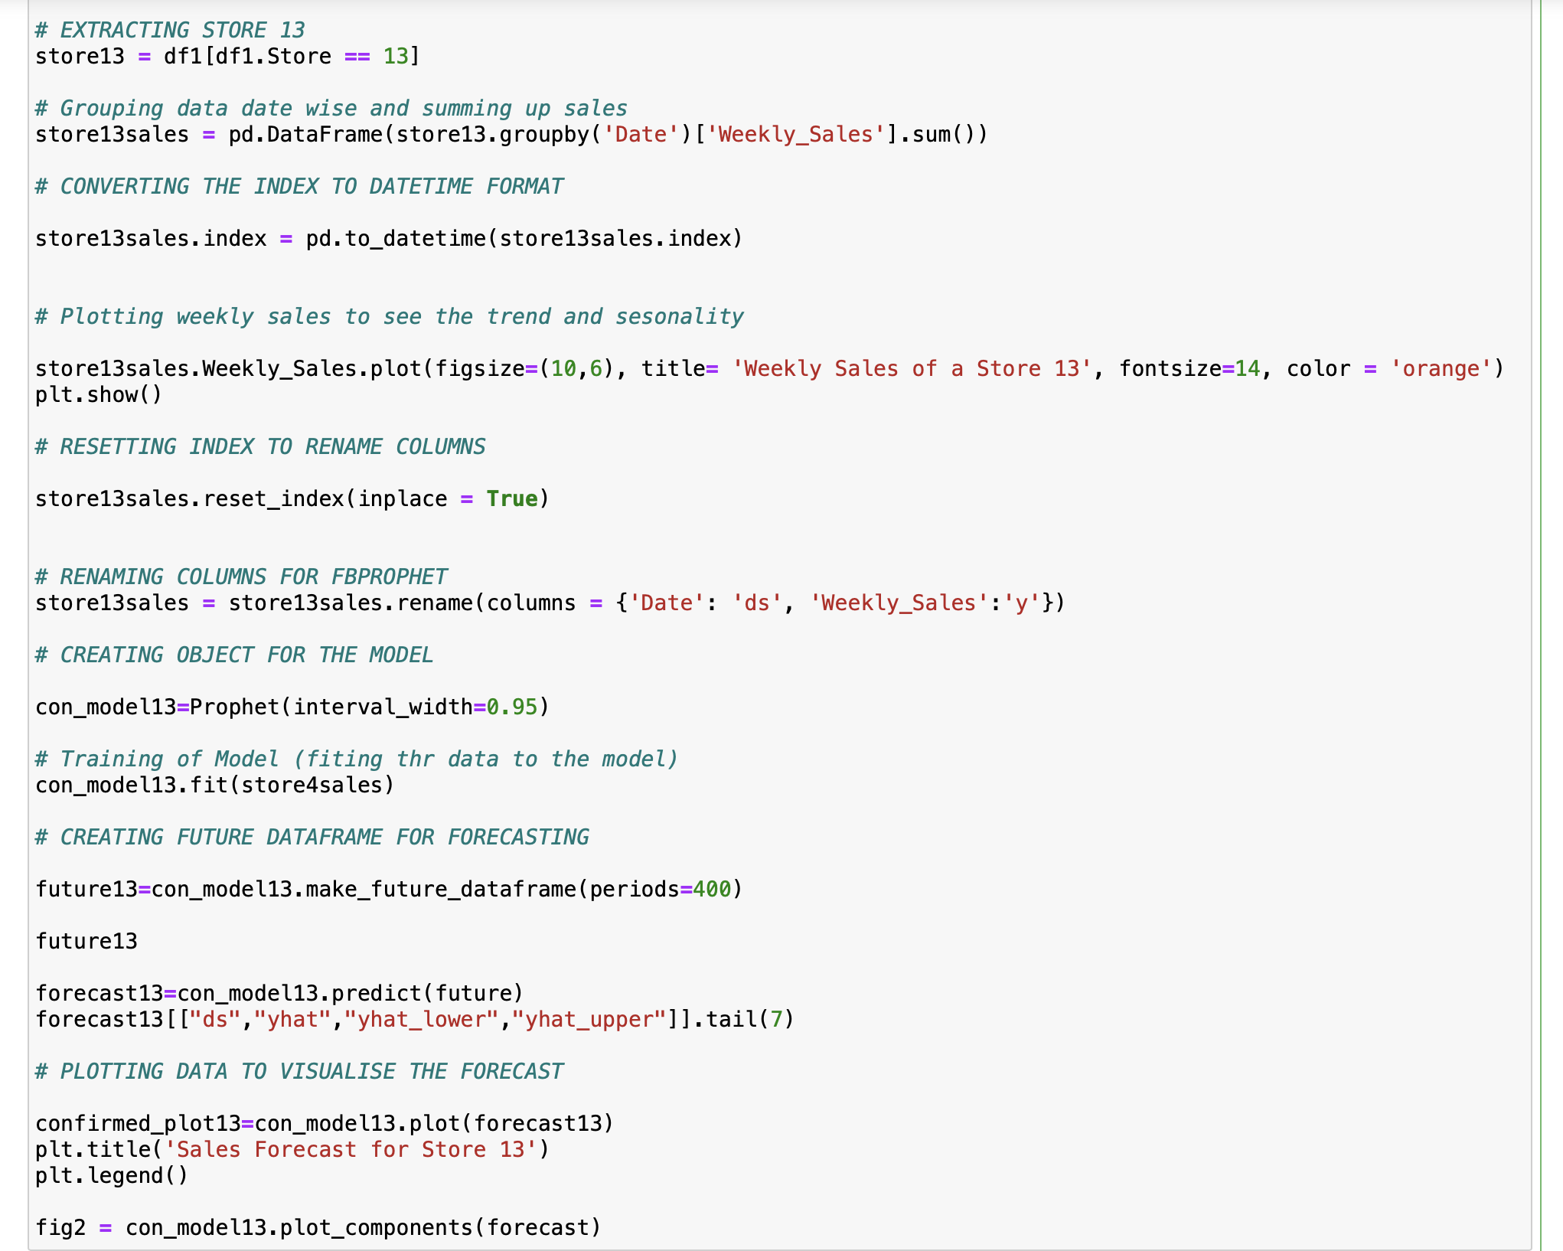

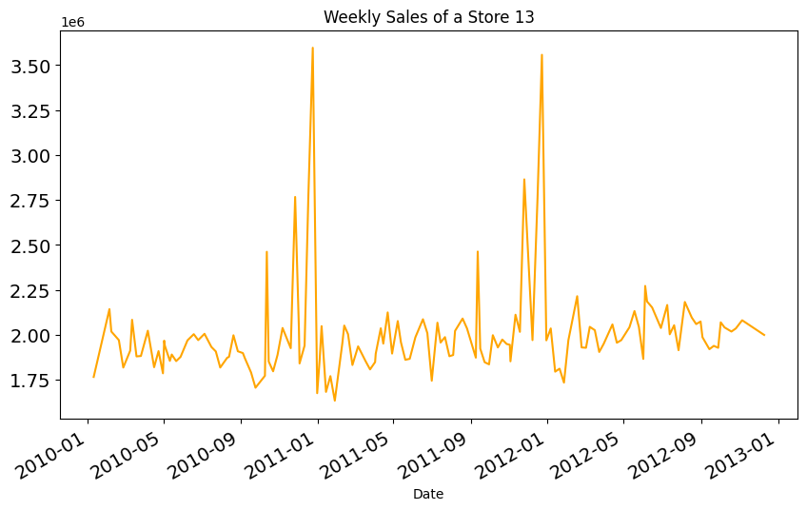

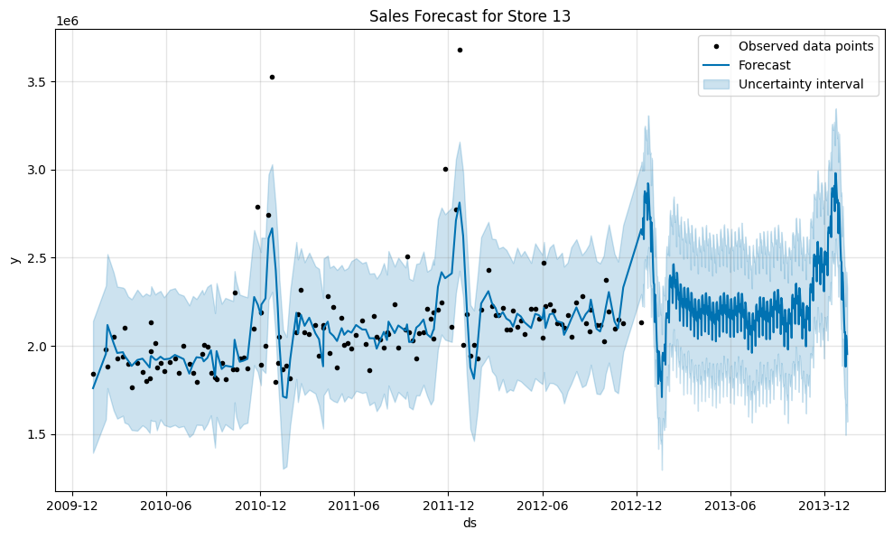



All the time series models have been put through cross validation and R2 metrics. I have evaluated for about 5 stores and all the stores except store 14 shows a similar or upward trend while store 14 is showing a downward trend in sales still maintaining seasonality.

Inferences

Time series is a great way to forecast sales of stores like Walmart based on multiple features. This model has robustly predicted the sales of 3 or more stores maintaining the seasonality.

I have used the fb prophet model to forecast sales of 3 or more stores. All the stores show sales similar or better to previous trend except Store 14.

We can increase the number of forecast periods to the desired values and predict the sales of these stores for the foreseeable future.

FUTURE POSSIBILITIES:

Once we have more recent data, we can incorporate other features and decide on the buying power and sales of stores. The main disadvantage of the Prophet model is that it tends to have subpar predictive performance when compared to classical time series models.

CONCLUSION:

This project was aimed at predicting sales of various Walmart stores. I have performed analysis of features and features engineering to get insights on various relationships the features have with the target Sales value.

I have chosen to go with Time series Analysis with Fb prophet model to get more interactive time series data. This shows the trend for the next 12 weeks across stores of Walmart.

REFERENCES:

https://towardsdatascience.com/an-end-to-end-project-on-time-series-analysis-and-forecasting-with-python-4835e6bf050b

<https://facebook.github.io/prophet/>

https://medium.com/analytics-vidhya/predicting-sales-time-series-analysis-forecasting-with-python-b81d3e8ff03f